Overfitting
Overfitting occurs when a machine learning model learns the training data too well, capturing noise or random fluctuations in the data rather than the underlying patterns. Here are several strategies to address overfitting:
1. Increase Data Volume:
- Collect more data to provide a more diverse and representative sample for the model to learn from.
2. Data Augmentation:
- Augment the existing data by applying random transformations (e.g., rotation, scaling, cropping) to artificially increase the size of the dataset.
3. Feature Selection:
- Choose a subset of relevant features and discard irrelevant ones. This can help the model focus on the most important information.
4. Regularization:
- Use regularization techniques like L1 or L2 regularization to penalize large weights in the model. This discourages the model from fitting the noise in the data.
5. Dropout:
- Apply dropout during training, where random neurons are temporarily dropped out or "ignored" during forward and backward passes. This helps prevent the model from relying too heavily on specific neurons.
6. Cross-Validation:
- Use techniques like cross-validation to assess how well the model generalizes to new data. This can help you detect overfitting early in the training process.
7. Simplify the Model:
- Reduce the complexity of the model architecture. This could involve decreasing the number of layers or nodes in each layer.
8. Ensemble Methods:
- Combine predictions from multiple models to improve generalization. Ensemble methods like bagging or boosting can help reduce overfitting.
9. Early Stopping:
- Monitor the model's performance on a validation set and stop training once the performance starts to degrade. This helps prevent the model from learning noise in the later stages of training.
10. Hyperparameter Tuning:
- Experiment with different hyperparameter values, such as learning rate, batch size, and the number of hidden units, to find configurations that prevent overfitting.
11. Use a Simpler Model:
- If possible, consider using a simpler model that is less prone to overfitting, especially if the dataset is small.
12. Check for Data Leakage:
- Ensure that there is no data leakage, where information from the test set inadvertently influences the training process.
13. Use Cross-Validation:
- Implement techniques like k-fold cross-validation to get a more reliable estimate of the model's performance on unseen data.
14. Monitor and Visualize:
- Regularly monitor the model's performance on both training and validation sets. Visualization techniques, such as learning curves, can provide insights into overfitting.
Applying a combination of these strategies can often help mitigate overfitting and improve the generalization performance of a machine learning model.

Sigmoid
The correct statement among the options provided is:
"is continuous and differentiable everywhere."
A sigmoid function is indeed continuous and differentiable everywhere. The sigmoid function is commonly used in neural networks, especially in the context of binary classification problems, to squash the output of a neuron or a layer between 0 and 1. The sigmoid function is given by:
sigma(x) = frac{1}{1 + e^{-x}}
This function takes any real number as input and maps it to a value between 0 and 1, making it useful for producing probabilities. However, it does not map to values between -1 and 1; instead, it maps to values in the range (0, 1).
The other statements are incorrect:
- A sigmoid layer typically does not have a learnable parameter itself; instead, the weights and biases in the layer are learnable during training.
- A sigmoid layer is used during backpropagation, and its derivatives can be calculated for gradient descent optimization.
- As mentioned, the sigmoid function maps to values between 0 and 1, not -1 and 1.

Training error does not decrease
If the training error does not decrease during the training of a machine learning model, several potential reasons could be considered:
1. Insufficient Model Capacity:
- The model may be too simple to capture the underlying patterns in the data. Increasing the complexity of the model, such as adding more layers or neurons, might be necessary.
2. Overfitting:
- The model may be overfitting the training data, capturing noise or specific patterns that do not generalize well to new data. In this case, regularization techniques or reducing model complexity might help.
3. Learning Rate Too High:
- A high learning rate can cause the model to overshoot the optimal parameter values during training, preventing convergence. Try reducing the learning rate to allow for more stable updates.
4. Learning Rate Too Low:
- Conversely, a learning rate that is too low might cause the model to converge very slowly. Gradually increasing the learning rate could help in such cases.
5. Data Quality Issues:
- Check for errors or inconsistencies in the training data. Noisy or incorrect data can hinder the model's ability to learn.
6. Data Scaling Issues:
- Features with different scales may impact the convergence of the optimization algorithm. Standardize or normalize the input features to have similar scales.
7. Vanishing or Exploding Gradients:
- If the model has deep layers, vanishing or exploding gradients might occur, making it difficult for the model to learn. Consider using techniques like batch normalization or gradient clipping.
8. Incorrect Hyperparameters:
- Check other hyperparameters such as batch size, the number of layers, or the choice of activation functions. Suboptimal hyperparameters can impede convergence.
9. Data Imbalance:
- In classification problems, imbalanced class distribution might cause the model to focus more on the majority class. Addressing class imbalance through techniques like oversampling or undersampling may help.
10. Bugs in Implementation:
- Check the code for bugs or mistakes in the implementation of the model, loss function, or optimization algorithm.
11. Random Initialization:
- The initial weights of the model might be set in a way that makes learning difficult. Experiment with different random initialization techniques.
12. Early Stopping:
- If early stopping is implemented, the training may stop before the model has converged. Adjust the patience parameter or disable early stopping to observe longer training.
13. Architecture Mismatch:
- The model architecture might not be suitable for the specific characteristics of the data. Experiment with different architectures that are more appropriate for the problem.
By systematically investigating these potential issues, you can often identify the root cause of the lack of improvement in training error and take appropriate corrective measures.
If there is too much regularization, it can also lead to a situation where the training error does not decrease effectively. Regularization methods, such as L1 regularization, L2 regularization, or dropout, are intended to prevent overfitting by penalizing large weights or discouraging co-adaptation of hidden units. However, excessive regularization can have the following effects:
1. Underfitting:
- Too much regularization can lead to a model that is too simple to capture the underlying patterns in the data. This results in underfitting, where the model is not able to learn the training data adequately.
2. Suppressed Model Complexity:
- Strong regularization suppresses the model's capacity to learn complex relationships in the data. If the data contains non-trivial patterns that the model needs to capture, excessive regularization can prevent it from doing so.
3. High Bias:
- The bias introduced by regularization may become too dominant, leading to high bias and poor model performance on both the training and validation sets.
4. Difficulty in Convergence:
- Excessive regularization may slow down the convergence of the optimization algorithm or prevent it from converging altogether. This is because the regularization terms dominate the loss function, making it difficult for the model to find a suitable parameter configuration.
To address the issue of too much regularization, you can consider the following steps:
- Reduce Regularization Strength:
- Adjust the hyperparameters controlling the strength of regularization (e.g., reduce the regularization coefficient in L1 or L2 regularization).
- Evaluate on Validation Set:
- Monitor the model's performance on a validation set. If the validation performance is significantly worse than the training performance, it might indicate that regularization is too strong.
- Experiment with Different Regularization Techniques:
- If using multiple regularization techniques, experiment with different combinations or focus on one type of regularization that seems more suitable for your specific problem.
- Cross-Validation:
- Use cross-validation to find an appropriate level of regularization that generalizes well to unseen data.
- Regularization for Specific Layers:
- Consider applying regularization to specific layers rather than the entire network. This allows more flexibility in controlling the regularization for different parts of the model.
- Check Regularization Type:
- Ensure that the chosen regularization method is appropriate for the problem at hand. For instance, L1 regularization promotes sparsity, which might not be suitable for all types of data.
By finding the right balance in regularization strength and type, you can prevent underfitting and improve the model's ability to generalize to new, unseen data. Regularization is a tool that should be carefully tuned based on the characteristics of the data and the complexity of the model.

Dropout
The correct statements among the options provided are:
1. "Is an efficient way for regularization."
- Dropout is indeed an effective regularization technique. It helps prevent overfitting by randomly dropping out (ignoring) a fraction of neurons during each training iteration, forcing the network to learn more robust features.
2. "Can be seen as an ensemble of networks."
- Dropout can be interpreted as training an ensemble of networks with shared weights. During training, different subsets of neurons are dropped out, leading to the training of different subnetworks. At test time, the predictions are averaged, resembling the behavior of an ensemble.
The incorrect statements are:
- "Has trouble with tanh activations."
- Dropout is generally compatible with various activation functions, including tanh. However, it is true that dropout might require adjusting the learning rate because it introduces additional noise during training. This adjustment is not specific to tanh activations.
- "Makes your network train faster."
- Dropout can slow down training initially because the network is effectively learning from a smaller, noisier version of itself during each iteration. However, it often leads to a more robust and generalizable model, potentially reducing the need for extensive hyperparameter tuning or careful weight initialization.
In summary, dropout is a powerful regularization technique that can be applied to various types of activation functions, and it can be viewed as an ensemble learning method.

Consider a simple convolutional neural network with a single convolutional layer.
The correct statement among the options provided is:
"It is translation invariant."
In a convolutional neural network (CNN) with a single convolutional layer, the use of convolutional operations introduces translation invariance. This means that the network can detect patterns or features regardless of their absolute position in the input.
The incorrect statements are:
- "All input nodes are connected to all output nodes."
- In a convolutional layer, only a local region of the input (determined by the filter size) is connected to each neuron in the output. This local connectivity is a key aspect of convolutional layers and helps in capturing spatial hierarchies of features.
- "It is scale invariant."
- CNNs are not inherently scale invariant. The learned filters operate on local regions of the input, and their effectiveness may be affected by changes in scale. Techniques like pooling can provide some degree of scale invariance, but it's not a guaranteed property.
- "It is rotation invariant."
- CNNs are not rotation invariant by default. The learned filters are sensitive to the orientation of features in the input. While data augmentation techniques such as random rotations during training can help improve robustness to rotation, CNNs themselves do not inherently possess rotation invariance.

You are building a model to predict the presence (labeled 1) or absence(labeled 0) of a tumor in a brain scan.
The goal is to ultimately deploy the model to help doctors in hospitals. Which of these two metrics would you choose to use?
In the context of building a model to predict the presence or absence of a tumor in a brain scan, the choice of evaluation metric depends on the specific requirements and priorities of the task. However, considering the nature of the problem and its implications, the metric that is often prioritized is:
Recall (Sensitivity or True Positive Rate):
Recall is the number of true positive predictions divided by the total number of actual positive instances. In the context of tumor prediction:
Recall = True Positives/(True Positives + False Negatives)
- Reasoning:
- High Recall is crucial in this medical context because it emphasizes minimizing false negatives (missing actual tumors). A false negative in this scenario means failing to detect a tumor that is actually present, which can have severe consequences for the patient.
- Concerns:
- While achieving high Recall is important, it might come at the cost of a lower Precision (higher false positive rate). In the medical field, false positives can lead to unnecessary anxiety or procedures, so it's essential to strike a balance depending on the specific application.
Note:
- Precision is also an important metric, as it measures the accuracy of positive predictions. However, in medical contexts where missing a positive (tumor) is often more critical than a false positive, Recall is often prioritized.
- Average Precision is typically used in scenarios where the precision-recall trade-off needs to be considered across different threshold values. It might be relevant if you are tuning your model to operate at various confidence thresholds.
Ultimately, it's advisable to consult with medical professionals and stakeholders to align the model evaluation metrics with the specific goals and implications in the medical domain.

1X1 Convolutions
1x1 convolutions, also known as network-in-network or pointwise convolutions, serve several important purposes in convolutional neural networks (CNNs). Despite their seemingly small size, they can have a significant impact on the network architecture. Here are some reasons why 1x1 convolutions are used:
1. Dimensionality Reduction:
- 1x1 convolutions are often employed to reduce the number of channels in the feature maps. By applying 1x1 convolutions with a smaller number of filters, the network can reduce the dimensionality of the feature space, which can be beneficial for computational efficiency.
2. Non-Linearity Introduction:
- Although the convolution itself is a linear operation, the subsequent application of activation functions (e.g., ReLU) after 1x1 convolutions introduces non-linearity to the network. This helps the network capture more complex relationships within the data.
3. Parameter Reduction:
- 1x1 convolutions can be used to reduce the number of parameters in the network. This can be particularly important in scenarios where model size and computational efficiency are crucial considerations.
4. Inter-Channel Correlations:
- 1x1 convolutions allow for modeling interactions between channels in a feature map. This is especially useful for capturing cross-channel dependencies and relationships.
5. Network-in-Network Structure:
- 1x1 convolutions were introduced as part of the Network-in-Network (NiN) architecture. NiN proposes the use of global average pooling and 1x1 convolutions to replace fully connected layers, promoting better parameter efficiency and reducing overfitting.
6. Integration with Other Layer Types:
- 1x1 convolutions can be seamlessly integrated with other convolutional layers, pooling layers, and even fully connected layers. This flexibility allows for the construction of more versatile and efficient network architectures.
7. Multi-Scale Feature Fusion:
- When used in combination with other convolutional layers with larger receptive fields, 1x1 convolutions facilitate multi-scale feature fusion. This enables the network to capture both local and global patterns in the input data.
8. Efficient Information Flow:
- 1x1 convolutions contribute to efficient information flow through the network by reducing the dimensionality in a controlled manner. This can help in preventing the network from becoming too computationally expensive.
In summary, 1x1 convolutions are a powerful tool in CNN architectures, offering benefits such as dimensionality reduction, non-linearity introduction, parameter reduction, and improved information flow. They are especially useful when designing efficient and parameter-efficient models for tasks such as image classification, segmentation, and feature learning.
The reasons for using 1x1 convolutions include:
1. Collapse Number of Channels:
- Correct Statement: 1x1 convolutions can be used to collapse or reduce the number of channels in the feature maps. This is achieved by applying 1x1 convolutions with a smaller number of filters, effectively performing a linear combination of input channels and reducing their dimensionality. This is especially useful for controlling model complexity and computational efficiency.
2. Predict Binary Class Probabilities:
- Incorrect Statement: While 1x1 convolutions are part of convolutional neural network architectures and contribute to tasks like classification, the direct prediction of binary class probabilities is more closely associated with the output layer and activation functions (e.g., sigmoid activation). 1x1 convolutions are often used in earlier layers for feature transformation and dimensionality reduction.
3. Learn More Complex Functions by Introducing Additional Non-Linearities:
- Partially Correct Statement: 1x1 convolutions themselves are linear operations, but when followed by non-linear activation functions (e.g., ReLU), they introduce non-linearities to the network. The non-linear activation functions are crucial for the network's ability to learn complex, non-linear relationships within the data.
4. To Enforce a Fixed Size Output:
- Incorrect Statement: The use of 1x1 convolutions alone does not inherently enforce a fixed size output. The spatial dimensions of the output depend on factors such as the stride and padding used in the convolutional layer. If fixed size output is desired, other architectural choices or additional operations may be necessary.
In summary, the primary and accurate reason for using 1x1 convolutions is to collapse the number of channels in feature maps, providing dimensionality reduction and control over model complexity. They are not specifically designed for predicting binary class probabilities or enforcing a fixed size output, although they contribute to these aspects as part of a larger network architecture.

RMSProp
RMSProp (Root Mean Square Propagation) is an optimization algorithm used to adapt the learning rates of individual parameters during training in order to speed up convergence and improve the overall training process. The concept behind RMSProp is to address the limitations of vanilla stochastic gradient descent (SGD) by adjusting the learning rates dynamically based on the historical gradient information.
RMSProp (Root Mean Square Propagation) is considered a first-order optimization algorithm. The term "first-order" refers to the fact that RMSProp only considers and utilizes first-order information, which includes gradients, to update the model parameters during optimization. In contrast, second-order optimization methods involve using second-order derivatives, such as the Hessian matrix.
Here's how RMSProp works:
1. Running Average of Squared Gradients:
- RMSProp maintains a running average of the squared gradients for each parameter. The running average is calculated using exponential decay, giving more weight to recent gradients while discounting older ones.
2. Update Rule:
- The update rule for the parameter (w) at iteration (t) is given by:
w_{t+1} = w_t - frac{eta}{sqrt{Eg^2_t + epsilon}} * g_t
where:
- (w_t) is the current value of the parameter.
- (eta) is the learning rate.
- (g_t) is the gradient of the loss with respect to the parameter at time (t).
- (Eg^2_t) is the exponentially decaying average of squared gradients up to time (t).
- (epsilon) is a small constant added for numerical stability.
3. Adaptive Learning Rates:
- The denominator term (sqrt{Eg^2_t + epsilon}) acts as an adaptive scaling factor for the learning rates. If the squared gradients have been consistently large, the denominator becomes larger, leading to a smaller effective learning rate. Conversely, if the gradients have been small, the effective learning rate increases.
4. Benefits:
- RMSProp helps to overcome some of the challenges of fixed learning rates in SGD. It adapts the learning rates on a per-parameter basis, allowing for faster convergence in scenarios where the gradients of different parameters vary widely or where the landscape of the loss function is non-uniform.
5. Numerical Stability:
- The addition of (epsilon) in the denominator ensures numerical stability, preventing division by very small values. This is particularly important when dealing with features with varying scales or when the optimization landscape has regions of very small gradients.
By adapting learning rates based on the historical information about gradients, RMSProp is effective in dealing with challenges such as slow convergence and oscillations in learning rate. This adaptive learning rate mechanism helps RMSProp converge faster and can be particularly useful in training deep neural networks.

Adam
The Stochastic Gradient Descent (SGD) variation that uses both first and second-order momentum is called Adam (Adaptive Moment Estimation). Adam is an optimization algorithm that combines ideas from both RMSProp and Momentum.
Here's how Adam works:
1. First-Moment Estimation (Mean of Gradients):
- Adam maintains an exponentially decaying average of past gradients (first moment), similar to the momentum term in classical momentum-based optimization algorithms. This is denoted by (m_t), and its update rule is:
m_t = beta_1 * m_{t-1} + (1 - beta_1) * g_t
where (g_t) is the gradient of the loss with respect to the parameters at time (t), and (beta_1) is a decay parameter close to 1.
2. Second-Moment Estimation (Uncentered Variance of Gradients):
- Adam maintains an exponentially decaying average of the squared gradients (second moment), similar to RMSProp. This is denoted by (v_t), and its update rule is:
v_t = beta_2 * v_{t-1} + (1 - beta_2) * g_t^2
where (g_t^2) is the element-wise square of the gradient.
3. Bias Correction:
- Both (m_t) and (v_t) are biased towards zero in the early iterations, especially when (t) is small. To correct this bias, Adam introduces a bias correction term for both (m_t) and (v_t):
hat{m}_t = frac{m_t}{1 - beta_1^t}
hat{v}_t = frac{v_t}{1 - beta_2^t}
4. Parameter Update:
- The actual parameter update is then performed using the bias-corrected first and second moments:
w_{t+1} = w_t - frac{eta}{sqrt{hat{v}_t} + epsilon} * hat{m}_t
where (w_t) is the current value of the parameter, (eta) is the learning rate, and (epsilon) is a small constant added for numerical stability.
Adam combines the advantages of momentum (first-order momentum) and RMSProp (second-order momentum) and adapts the learning rates for each parameter individually based on the historical gradients and squared gradients. This adaptability often makes Adam more effective in practice, especially in the training of deep neural networks.
In the context of optimization algorithms like Adam, the terms "first-order moment" and "second-order moment" refer to different statistical moments calculated during the optimization process. Let's break down what each of these terms means:
1. First-Order Moment:
- The first-order moment is often referred to as the "mean" or "average." In the context of optimization algorithms, it is specifically the average of the gradients of the loss function with respect to the parameters over time. Mathematically, it is denoted as (m_t) and is calculated using an exponentially decaying average:
m_t = beta_1 * m_{t-1} + (1 - beta_1) * g_t
Here, (m_t) is the first-order moment at time (t), (g_t) is the gradient of the loss with respect to the parameters at time (t), and (beta_1) is a decay parameter close to 1.
2. Second-Order Moment:
- The second-order moment is often referred to as the "variance" or "uncentered second moment." In the context of optimization algorithms, it is specifically the average of the squared gradients of the loss function with respect to the parameters over time. Mathematically, it is denoted as (v_t) and is calculated using an exponentially decaying average:
v_t = beta_2 * v_{t-1} + (1 - beta_2) * g_t^2
Here, (v_t) is the second-order moment at time (t), (g_t) is the gradient of the loss with respect to the parameters at time (t), and (beta_2) is a decay parameter close to 1.
These moments are used in optimization algorithms like Adam to adaptively adjust the learning rates for each parameter during training. The first-order moment helps capture the direction of the gradients, and the second-order moment helps capture the scale or magnitude of the gradients. Combining these moments allows for more effective and adaptive optimization, especially in the presence of varying and complex landscapes of loss functions.
What is the bias correction in the ADAM optimizer? Explain the problem that it fixes.
When accumulating gradients in a weighted average fashion, the first gradient is initialized to zero. This biases all the accumulated gradients down towards zero. The Bias correction normalizes the magnitude of the accumulated gradient for early steps.
The bias correction in the ADAM optimizer refers to a correction applied to the estimates of the first and second moments of the gradients during the training process. It addresses the issue of bias in the moving averages used by ADAM, particularly in the initial steps of training.
Here's an overview of the problem and how the bias correction is applied:
Problem:
ADAM maintains exponentially decaying averages of past gradients (first moments) and the squared gradients (second moments). These moving averages are used to adaptively adjust the learning rates for each parameter. However, in the early steps of training, when the averages are initialized, they can be biased toward zero, leading to suboptimal performance.
Bias Correction:
To mitigate this bias, a correction term is introduced during each update of the moving averages. This correction is applied to both the estimates of the first and second moments. The correction involves dividing the moving averages by a factor that depends on the current iteration or time step.
For the first moment (mean or gradient), the correction term is (1 - \beta_1^t), and for the second moment (variance or squared gradient), the correction term is (1 - \beta_2^t), where \beta_1 and \beta_2 are the decay rates for the first and second moments, respectively, and t is the time step.
Purpose:
The bias correction in ADAM helps to counteract the initialization bias in the moving averages, making the optimization process more stable, especially in the early training stages. By incorporating these correction terms, ADAM ensures that the averages converge to unbiased estimates over time, leading to more accurate and adaptive learning rate adjustments.
In summary, the bias correction in ADAM is a mechanism that improves the reliability of the estimates of the first and second moments of the gradients by compensating for the initialization bias. This contributes to the effectiveness and stability of the ADAM optimizer during the training of neural networks.

Saddle Point
A saddle point is a critical point in the optimization landscape of a function where the gradient is zero but is not a minimum or maximum. At a saddle point, the surface of the function resembles the shape of a saddle, where there are directions along which the function increases and directions along which it decreases.
Mathematically, at a saddle point (x), the gradient of the function is zero ((nabla f(x) = 0)), but the Hessian matrix (second-order derivative) has both positive and negative eigenvalues. This means that the curvature of the function in some directions is concave (negative eigenvalues) and in other directions is convex (positive eigenvalues).
Advantage/Disadvantage of Stochastic Gradient Descent (SGD) in Dealing with Saddle Points:
1. Advantage: Escape from Saddle Points:
- Stochastic Gradient Descent (SGD) has a potential advantage in escaping saddle points due to its inherent stochastic nature. In SGD, a random subset of training examples (mini-batch) is used to compute the gradient at each iteration. The noise introduced by the stochasticity can help the optimization process escape from flat regions, including saddle points.
2. Advantage: Noise in Gradient Updates:
- The noise introduced by the random sampling of examples in SGD can perturb the optimization process and make it more likely to move away from the saddle points. The noisy updates can prevent the optimization from getting stuck in the flat regions.
3. Disadvantage: Slow Convergence:
- While SGD might help escape from saddle points, it can also slow down the convergence process. The noise in the updates can lead to oscillations and slower progress towards the optimal solution, especially in regions of the optimization landscape where the gradient is not consistent.
4. Disadvantage: Potential for Overshooting:
- The stochasticity in SGD introduces variability in the direction of the gradient updates. In some cases, this variability can lead to overshooting the optimal solution, causing the optimization process to oscillate around the minimum instead of converging.
5. Disadvantage: Noisy Gradient Estimates:
- The stochasticity in SGD introduces noise in the gradient estimates, which can result in noisy updates. This noise can make it challenging to accurately estimate the true direction of the steepest decrease in the loss function.
In summary, while SGD has the advantage of being able to escape from saddle points due to its stochastic nature, it also comes with the disadvantage of introducing noise in the optimization process, potentially leading to slower convergence and oscillations. Techniques such as momentum, learning rate schedules, and advanced optimization algorithms (e.g., Adam) are often employed to mitigate some of these challenges and enhance the performance of SGD.

Why would one want to use larger mini-batches in SGD?
Using larger mini-batches in Stochastic Gradient Descent (SGD) can offer several advantages, depending on the specific characteristics of the optimization problem and the computational resources available. Here are some reasons why one might want to use larger mini-batches:
1. Computational Efficiency:
- Larger mini-batches can take better advantage of parallel processing capabilities, especially when training on hardware like GPUs. This can lead to faster computation times and more efficient utilization of hardware resources.
2. Memory Efficiency:
- Larger mini-batches require less frequent communication between the CPU and GPU, leading to improved memory efficiency. This is important when working with large datasets that might not fit entirely into the GPU memory.
3. Stable Gradient Estimates:
- With larger mini-batches, the stochastic noise introduced by individual data points is reduced. This can lead to more stable gradient estimates, resulting in less variance in the updates and potentially smoother convergence.
4. Better Hardware Utilization:
- Training with larger mini-batches can lead to more efficient use of high-performance computing resources. GPUs are often designed to handle parallel computations efficiently, and larger mini-batches can exploit this parallelism more effectively.
5. Regularization Effect:
- Larger mini-batches can have a regularization effect similar to dropout. The noise introduced by small mini-batches acts as a form of regularization, preventing the model from fitting the training data too closely and potentially improving generalization to unseen data.
6. Reduced Parameter Update Frequency:
- With larger mini-batches, the parameter updates are less frequent, leading to a smoother optimization process. This can be beneficial for models with complex loss landscapes, preventing the model from overreacting to noisy or outlier data points.
7. Improved Generalization:
- In some cases, using larger mini-batches might result in improved generalization performance. The additional stability provided by larger mini-batches could lead to better convergence and more accurate models on validation and test sets.
8. Reduced Overhead:
- Mini-batch processing incurs some overhead in terms of data loading and model evaluation. Larger mini-batches reduce the relative overhead associated with these operations, leading to more efficient training.
It's important to note that the choice of mini-batch size is a hyperparameter that depends on various factors, including the specific characteristics of the dataset, model architecture, and available hardware. While larger mini-batches offer certain advantages, there is no one-size-fits-all solution, and the optimal mini-batch size might need to be determined through experimentation and validation.

Why do we usually use small mini-batches in practice?
In practice, small mini-batches are often used in Stochastic Gradient Descent (SGD) and its variants for several reasons:
1. Stochasticity and Regularization:
- Small mini-batches introduce a level of stochasticity into the optimization process. The stochastic nature helps the optimization algorithm escape from local minima and navigate complex loss landscapes, acting as a form of regularization. This randomness can prevent the model from memorizing the training data and improve generalization to unseen data.
2. Memory Efficiency:
- Training with small mini-batches is memory-efficient, especially when dealing with large datasets that might not fit entirely into the available GPU memory. The small batches allow for the model to be trained on subsets of the data, enabling efficient use of memory resources.
3. Faster Iterations:
- Smaller mini-batches lead to more frequent parameter updates, allowing the model to adapt quickly to changing patterns in the data. Faster iterations can accelerate the training process, especially when computational resources are limited.
4. Reduced Computational Overhead:
- Small mini-batches reduce the computational overhead associated with each iteration. The time required to load and preprocess a small batch of data is typically lower, making the training process more computationally efficient.
5. Parallelization and Hardware Utilization:
- Small mini-batches are well-suited for parallel processing, especially on hardware like GPUs. The parallel nature of small-batch training allows for efficient utilization of the available computational resources, leading to faster training times.
6. Adaptability to Online Learning:
- Small mini-batches are conducive to online learning scenarios where data is continuously streaming. The model can be updated frequently as new data becomes available, enabling real-time adaptation to changing patterns.
7. Diversity in Gradient Updates:
- Training with small mini-batches introduces diversity in the updates of the model parameters. Each mini-batch provides a different perspective on the data, contributing to a more varied exploration of the optimization landscape.
8. Gradient Noise:
- The noise introduced by small mini-batches in the gradient estimates helps the optimization process explore different regions of the loss landscape. This stochasticity can prevent the optimization from getting stuck in local minima or saddle points.
It's worth noting that the choice of mini-batch size is a hyperparameter, and the optimal size depends on factors such as the dataset size, model architecture, and available computational resources. While small mini-batches are commonly used, researchers and practitioners often experiment with different sizes to find the configuration that works best for a specific task.

Your network’s training curve diverges (assuming data loading is correct). Name one way to address the problem through hyperparameter change.
If your network's training curve is diverging, indicating that the training process is not converging as expected, one way to address the problem through hyperparameter changes is by adjusting the learning rate. The learning rate is a critical hyperparameter in training neural networks, and an inappropriate choice can lead to issues such as divergence.
Adjusting the learning rate is a common approach to stabilize the training process and guide the optimization towards convergence. If the divergence persists, other hyperparameters such as batch size, weight decay, or model architecture may also need to be examined and adjusted accordingly.

What is an epoch?
In the context of training machine learning models, an epoch is a single pass through the entire training dataset. During one epoch, the model processes each training example once and updates its weights based on the computed gradients. The number of epochs is a hyperparameter that determines how many times the learning algorithm will work through the entire training dataset.

When is SGD guaranteed to converge to a local minima (provide formula)?
The Robbins-Monro condition is a theoretical condition that, when satisfied, ensures the convergence of stochastic approximation algorithms, including Stochastic Gradient Descent (SGD). The condition is named after Herbert Robbins and Sutton Monro, who introduced it in the context of stochastic approximation.
The Robbins-Monro condition is expressed mathematically as follows:
sum_{t=1}^{infty} alpha_t = infty
sum_{t=1}^{infty} alpha_t^2 < infty
Here:
- (alpha_t) is the learning rate at iteration (t).
These conditions state that the learning rates should be chosen such that the sum of the learning rates diverges to infinity, ensuring sufficient exploration of the parameter space, and the sum of the squared learning rates converges to a finite value, preventing the learning rates from decreasing too quickly.
In the context of stochastic approximation algorithms like SGD, the Robbins-Monro condition ensures that the learning rates are appropriately tuned to balance exploration and exploitation during the optimization process. It helps guarantee the convergence of the algorithm under certain assumptions, such as the stationarity of the underlying distribution.
While the Robbins-Monro condition provides theoretical insights into the convergence of stochastic approximation algorithms, it's important to note that in practical machine learning applications, satisfying these conditions exactly may be challenging. Additionally, the optimization landscape, the choice of learning rates, and the complexity of deep neural networks introduce additional factors that influence convergence.
In practice, practitioners often use heuristics, learning rate schedules, and adaptive optimization algorithms to dynamically adjust the learning rates during training. These methods aim to balance the need for exploration and exploitation while avoiding issues such as divergence or convergence to suboptimal solutions.

Receptive Field
The receptive field refers to the region in the input space that affects a particular unit (neuron or feature) in the output space of a convolutional neural network (CNN). The receptive field size is determined by the size of the convolutional kernels, the number of convolutional layers, and the strides applied.
In this case, you have three convolutional layers, each with 5 filters and 3x3 kernels, applied with a stride of 1 and no padding. Let's calculate the receptive field size after these three convolutional operations.
For each convolutional layer, the receptive field size (RF) is calculated as follows:
RF_new = (RF_prev- 1) * stride + kernel_size
Initially, before any convolution, the receptive field is 1x1 (considering a single unit). After the first convolutional layer:
RF_1 = (1 - 1) * 1 + 3 = 3
After the second convolutional layer:
RF_2 = (3 - 1) * 1 + 3 = 5
After the third convolutional layer:
RF_3 = (5 - 1) *1 + 3 = 7
So, after the three convolutional layers, the receptive field size is 7x7 for each unit in the output feature map. This means that each unit in the final feature map is influenced by a 7x7 region in the input space.
ResNet (Residual Network)
A ResNet block, short for Residual Network block, consists of residual connections that allow the network to learn residual functions. The basic building block of a ResNet is the "Residual Block" or "ResBlock." Let's describe the operations inside a basic ResBlock and discuss its advantages.
Residual Block Operations:
A ResNet block typically has two main paths: the identity path and the shortcut path.
1. Identity Path:
- The identity path is the "skip connection" that directly passes the input to the output without any transformation.
- The input X is added element-wise to the output of the residual block.
- Mathematically, if F represents the residual function (the operations inside the block), the output Y is given by: Y = F(X) + X.
2. Shortcut Path:
- The shortcut path involves a series of operations to transform the input X.
- Common operations include batch normalization, followed by a non-linear activation function (e.g., ReLU), and a series of convolutional layers.
3. Advantages of Residual Blocks:
- Addressing Vanishing Gradient Problem:
- Residual connections help mitigate the vanishing gradient problem. In deep networks, as gradients are backpropagated through many layers, they can become extremely small, leading to slow or stalled learning. The direct skip connection allows gradients to flow more easily.
- Facilitating Training of Deeper Networks:
- The presence of skip connections makes it easier to train deeper networks. With traditional deep networks, as the depth increases, the performance can saturate or degrade. Residual connections enable the learning of identity mappings, allowing the network to choose to bypass certain layers if needed.
- Encouraging Feature Reuse:
- The identity path facilitates the reuse of features from earlier layers, promoting the learning of more abstract and high-level representations.
- Improving Convergence:
- Residual connections help the optimization process by making it easier for the network to learn both the identity mapping and the residual mapping. This can lead to faster convergence during training.
- Residual Learning Intuition:
- The residual learning idea is intuitive. I0f the optimal mapping for a layer is close to an identity function, it is easier to learn the residual rather than the entire mapping from scratch.
- Efficient Learning:
- Residual connections enable efficient learning by allowing the network to choose how much of the information from the previous layer to preserve or transform.
Help prevent vanishing gradients / Provides highway for the gradients in backward pass
In summary, ResNet blocks with residual connections provide a powerful mechanism for training very deep neural networks. The use of skip connections helps alleviate optimization challenges associated with deep architectures and enables the training of models with hundreds or even thousands of layers.
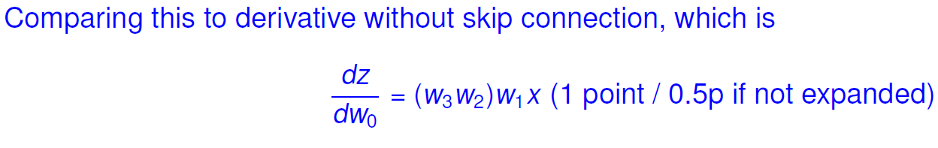
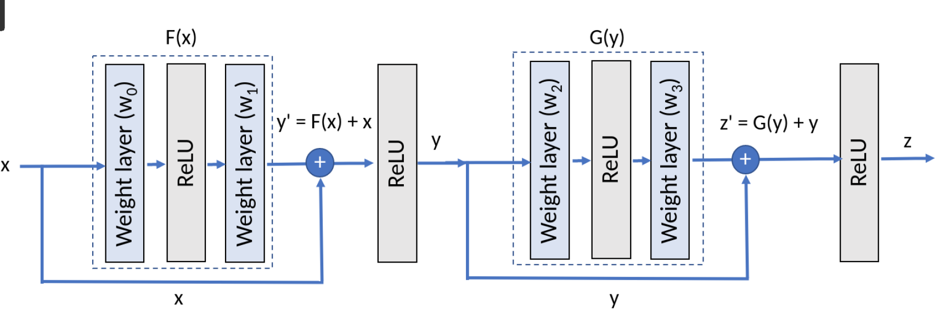
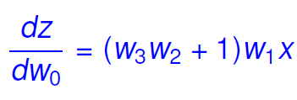

The extra ‘+1’ term in the skip connection derivative help propagation of gradient flow, preventing vanishing gradients.

You train a neural network and the loss diverges. What are reasonable things to do?
When you encounter a situation where the loss of a neural network diverges during training, it indicates that the optimization process is not progressing as expected. Here are several reasonable steps to investigate and address the issue:
1. Learning Rate Adjustment:
- Decrease the Learning Rate:
If the learning rate is too high, the optimization process may overshoot the minimum and lead to divergence. Try reducing the learning rate to allow for smaller weight updates.
2. Check Data and Preprocessing:
- Data Quality:
Ensure that your training data is clean and well-preprocessed. Check for outliers, missing values, or other issues in the data.
- Normalization:
Normalize or standardize the input features to ensure that they are on a similar scale. Extreme values can impact the training process.
3. Weight Initialization:
- Poorly initialized weights can contribute to convergence issues. Consider using appropriate weight initialization techniques, such as He initialization or Xavier initialization.
4. Model Architecture:
- Check Model Complexity:
A model that is too complex may overfit to the training data and struggle to generalize. Consider simplifying the model architecture or using regularization techniques.
- Gradient Clipping:
Implement gradient clipping to prevent exploding gradients. This involves setting a threshold beyond which gradients are scaled to avoid large updates.
5. Regularization Techniques:
- L1 or L2 Regularization:
Apply L1 or L2 regularization to penalize large weights and prevent overfitting.
- Dropout:
Introduce dropout layers to randomly deactivate some neurons during training, preventing over-reliance on specific features.
6. Batch Size:
- Adjust the batch size. Smaller batch sizes may introduce noise and prevent convergence. Experiment with different batch sizes to find a balance.
7. Check Loss Function:
- Ensure that the chosen loss function is appropriate for your task. For example, using binary cross-entropy for a regression task may lead to divergence.
8. Monitoring and Logging:
- Implement extensive logging and monitoring during training to identify when and where the divergence occurs. Check for NaN (Not a Number) or Inf (Infinity) values in the loss and gradients.
9. Early Stopping:
- Implement early stopping based on a validation metric. If the model performance on a validation set starts deteriorating, stop training to prevent overfitting.
10. Optimization Algorithm:
- Consider using a different optimization algorithm. While stochastic gradient descent (SGD) is common, adaptive algorithms like Adam or RMSProp may converge faster.
11. Check for Bugs:
- Examine the code for bugs, typos, or implementation errors. Sometimes, a small mistake can lead to unexpected behavior.
12. Reduce Model Capacity:
- If you are using a deep and complex model, consider reducing its capacity. A simpler model might be more stable during training.
Experiment with these suggestions iteratively and monitor the training process closely. It's often a combination of factors that contribute to divergence, and a systematic approach to debugging and experimentation is crucial for resolving the issue.

You want to train an autoencoder to overfit a single image with a fixed learning rate. Setting numerical precision aside, which loss function is able to reach zero loss after training with gradient descent.
In the context of overfitting a single image with a fixed learning rate, theoretically, the L2 loss (Mean Squared Error) is more likely to reach zero loss after training with gradient descent compared to the L1 loss (Mean Absolute Error).
The reason is that the L2 loss penalizes large errors more severely than the L1 loss due to the squaring of the differences between predicted and true values. Consequently, the optimization process tends to drive the errors to smaller values, potentially allowing the loss to reach zero, especially when overfitting a single image.

Regularization
The correct statements about regularization are:
1. Is a technique that aims to reduce the generalization gap.
- Explanation: Regularization techniques are designed to prevent overfitting and improve the generalization of a model to unseen data. By adding a penalty term to the loss function, regularization discourages the model from fitting the training data too closely and encourages it to find a more general solution.
2. Dropout, the use of ReLU activation functions, and early stopping can all be considered regularization techniques.
- Explanation: Dropout, ReLU activation functions, and early stopping are indeed regularization techniques.
- Dropout: Involves randomly deactivating some neurons during training to prevent over-reliance on specific features or neurons.
- ReLU Activation: The rectified linear unit (ReLU) activation function introduces non-linearity and can help prevent overfitting.
- Early Stopping: Involves halting the training process when the performance on a validation set stops improving, preventing overfitting.
3. Weight decay (L2) is commonly applied in neural networks to spread the decision power among as many neurons as possible.
- Explanation: Weight decay (L2 regularization) is applied to neural networks to penalize large weights and encourage the model to use all neurons more evenly. It helps prevent individual neurons from becoming too dominant in the decision-making process.
The incorrect statement is:
4. ~~Is a technique that aims to reduce your validation error and increases your training accuracy.~~
- Correction: Regularization primarily aims to improve generalization and reduce overfitting, which can lead to better performance on validation data. It does not necessarily guarantee an increase in training accuracy.

Rectified Linear Unit (ReLU) applied in a CNN
Let's evaluate each statement:
1. Despite a small learning rate, without saturation the gradients are very likely to explode.
- Incorrect: ReLU activation does not saturate for positive input values, so if the learning rate is too high, the gradients may explode during backpropagation. But for small learning rate, the gradients are not very likely to explode.
2. A large negative bias in the previous layer can cause the ReLU to always output zero.
- Correct: If the input to the ReLU is a large negative value (due to a large negative bias in the previous layer), the ReLU will output zero, and the gradient during backpropagation will be zero, potentially causing the "dying ReLU" problem.
3. Large and consistent gradients allow for a fast network convergence.
- Correct: ReLU can provide large gradients for positive input values, contributing to faster convergence compared to saturating activation functions like sigmoid or tanh.
4. Max pooling must always be applied after the ReLU.
- Incorrect: Max pooling does not have to be applied after ReLU. The order of operations in a CNN can vary, and max pooling is often applied before or after activation functions based on the design of the network. It's a common practice to apply ReLU after convolution and before pooling, but it's not a strict requirement.

Your train and val loss converge to about the same value.
When the training and validation loss converge to about the same value, it generally indicates that the model is not exhibiting significant overfitting or underfitting. Here's what this convergence in losses might mean:
1. Good Generalization:
- The model has learned to generalize well to unseen data (validation set) and is not overfitting the training data. The similarity in training and validation losses suggests that the model is performing consistently on both datasets.
2. Appropriate Model Complexity:
- The model's capacity is likely suitable for the complexity of the underlying patterns in the data. It is neither too simple (underfitting) nor too complex (overfitting), striking a good balance.
3. Effective Training:
- The training process has been effective in optimizing the model's parameters. The model has learned to capture relevant features without fitting the noise in the training data excessively.
4. Regularization May Be Balanced:
- If regularization techniques are applied, they may be appropriately balancing the trade-off between fitting the training data and generalizing to new data.
While the convergence of training and validation losses is generally positive, it's important to consider other aspects as well:
- Convergence Speed:
- Evaluate the convergence speed. Faster convergence might be desirable, and adjustments to learning rate or model capacity could be explored.
- Evaluation Metrics:
- Consider additional evaluation metrics, such as accuracy, precision, recall, or F1 score, to obtain a more comprehensive understanding of the model's performance.
- Domain-Specific Considerations:
- Depending on the specific characteristics of the task and dataset, further analysis may be required. For example, in some cases, a small gap between training and validation loss may be acceptable.
In summary, the convergence of training and validation losses suggests a well-generalized model, but it's crucial to consider other factors and performance metrics for a comprehensive assessment of the model's effectiveness.
What would you do to increase the performance of your model if your train and val loss converge to about the same value?
If the training and validation losses have already converged to a similar value and you aim to further improve the performance of your model, consider the following strategies:
1. Increase Model Complexity:
- If your model is not capturing the complexity of the underlying patterns in the data, consider increasing its capacity. This could involve adding more layers, increasing the number of neurons, or using a more sophisticated architecture.
2. Fine-Tune Hyperparameters:
- Experiment with hyperparameters, such as learning rate, batch size, and regularization strength. Small adjustments to these parameters can sometimes have a significant impact on performance.
3. Data Augmentation:
- Apply data augmentation techniques to artificially increase the diversity of your training data. This can be particularly beneficial for tasks like image classification.
4. Feature Engineering:
- Explore additional features or transformations that might improve the model's ability to capture relevant patterns in the data.
5. Ensemble Methods:
- Consider using ensemble methods by training multiple models and combining their predictions. Ensemble methods can often lead to improved performance by leveraging diverse models.
6. Evaluate Different Architectures:
- Experiment with different model architectures. Try different types of layers, activation functions, or skip connections to find a configuration that enhances performance.
7. Regularization Techniques:
- While regularization may already be applied, consider experimenting with different regularization techniques or adjusting the strength of existing regularization methods. Be cautious not to over-regularize.
8. Learning Rate Schedules:
- Implement learning rate schedules or dynamic learning rates. Gradually decreasing the learning rate during training can sometimes lead to improved convergence.
9. Evaluate Class Imbalances:
- If your dataset has class imbalances, consider addressing this issue, as it might affect the model's performance.
10. Check for Data Quality:
- Ensure that your training and validation data are of high quality. Check for anomalies, outliers, or mislabeled samples that might be affecting the model's performance.
Remember to experiment with these strategies iteratively, monitor the performance on the validation set, and choose the combination of techniques that provides the best trade-off between bias and variance for your specific problem.

An autoencoder
The statement "An autoencoder is often used for fine-tuning pre-trained models" is not accurate in the standard use of autoencoders.
Autoencoders are primarily used for unsupervised learning, where they learn to encode and decode input data without the need for pre-training on specific tasks. Pre-training and fine-tuning are concepts more commonly associated with supervised learning, especially in the context of pre-training deep neural networks on large labeled datasets and then fine-tuning them on specific tasks.
In the case of autoencoders, they are typically trained in an unsupervised manner to learn useful representations of data. While the learned features can be transferred and used for downstream tasks, it's not a common practice to refer to this process as "fine-tuning" in the same way it is for pre-trained models in supervised learning.
The correct statements are:
1. An autoencoder has a bottleneck layer.
- Explanation: An autoencoder typically consists of an encoder and a decoder, and it has a bottleneck layer in the middle that represents a compressed or encoded representation of the input data.
The incorrect statements are:
1. ~~An autoencoder has no loss function.~~
- Correction: Autoencoders do have a loss function. The loss function measures the difference between the input and the reconstructed output, encouraging the model to learn a compact representation that captures important features.
2. ~~An autoencoder requires class labels for training.~~
- Correction: Autoencoders are typically trained in an unsupervised manner and do not require class labels. They learn to encode and decode data without explicit class information. However, class labels may be used in certain variants or in conjunction with other techniques for specific tasks.

Why do we use Kaiming initialization instead of Xavier in the case of ReLU?
The Kaiming initialization, also known as He initialization, is preferred over Xavier initialization in the case of rectified linear unit (ReLU) activations because it takes into account the specific characteristics of ReLU non-linearities.
The key reason for using Kaiming initialization with ReLU is to address the issue of the vanishing gradient problem. The vanishing gradient problem occurs when the gradients during backpropagation become very small, leading to slow or stalled learning. ReLU activation units can contribute to this problem because they can "kill" activations by setting them to zero for negative inputs. If the weights are not properly initialized, the network may start with all ReLU units being inactive (outputting zero), and during training, the gradients can become very small, impeding the learning process.
Xavier initialization assumes a linear activation function and aims to keep the variance of activations roughly constant across different layers. However, with ReLU, the variance can be significantly reduced due to the half-rectification nature of ReLU units (output is zero for negative inputs). This reduction in variance can lead to gradients that are too small during backpropagation.

Kaiming initialization takes into account the specific properties of ReLU by scaling the weights with ( sqrt{frac{2}{n}} ), where ( n ) is the number of input units. This scaling compensates for the reduction in variance caused by ReLU, providing a better starting point for training. In essence, Kaiming initialization helps to prevent the vanishing gradient problem and promotes more effective training of deep neural networks with ReLU activations.
In summary, Kaiming initialization is tailored to the characteristics of ReLU, addressing potential issues related to the vanishing gradient problem and improving the convergence and performance of deep neural networks using ReLU activations.
Xavier initialization variance: 1/n
Kaiming initialization variance: 2/n

Name two reasons to use an inception layer in favor of a standard convolutional layer
The Inception layer, introduced by the Inception architecture (GoogLeNet), is designed to improve the representational capacity of a neural network by using multiple filter sizes in parallel. Here are two reasons to use an Inception layer in favor of a standard convolutional layer:
1. Multiscale Feature Extraction:
- Inception layers use filters of different sizes (1x1, 3x3, 5x5) in parallel. This allows the network to capture features at multiple scales simultaneously.
- The utilization of multiple filter sizes helps the network to learn both fine-grained details (captured by smaller filters) and broader patterns or context (captured by larger filters) in the input data.
- By combining features from different scales, the network becomes more robust to variations in object size and scale within the input images.
2. Increased Network Efficiency:
- Inception layers are designed to improve computational efficiency by using 1x1 convolutions to reduce the dimensionality before applying larger filters.
- 1x1 convolutions act as bottleneck layers, reducing the number of input channels before the more computationally expensive larger convolutions.
- This dimensionality reduction helps in reducing the overall number of parameters and computations, making the network more computationally efficient and allowing for deeper architectures without a significant increase in computational cost.
In summary, an Inception layer provides a way to capture multiscale features and increase computational efficiency, making it beneficial in scenarios where both fine-grained and global information are important for the task at hand.
So: Avoid choosing kernel size / dimensionality reduction leads to lower computational cost

What are the definitions of bias and variance in the context of machine learning?
In the context of machine learning, bias and variance are two important sources of error that contribute to the overall performance of a model. Understanding bias and variance is crucial for assessing the generalization ability of a machine learning algorithm.
1. Bias:
- Definition: Bias refers to the error introduced by approximating a real-world problem, which may be highly complex, by a simplified model.
- Explanation: A model with high bias is too simplistic and tends to underfit the training data. It fails to capture the underlying patterns in the data and makes strong assumptions that may not hold in the real-world scenario. High bias can lead to systematic errors across different datasets.
2. Variance:
- Definition: Variance represents the model's sensitivity to fluctuations or changes in the training data.
- Explanation: A model with high variance is too complex and fits the training data too closely. As a result, it may capture noise and fluctuations in the training set that do not generalize well to new, unseen data. High variance can lead to overfitting, where the model performs well on the training data but poorly on new, unseen data.
In summary:
- Bias is related to underfitting: A model with high bias doesn't capture the complexity of the underlying data, leading to systematic errors.
- Variance is related to overfitting: A model with high variance fits the training data too closely, capturing noise and leading to poor generalization to new data.
The balance between bias and variance is crucial for building a model that generalizes well to unseen data. This trade-off is often referred to as the bias-variance trade-off. The goal is to find a model that strikes the right balance, minimizing both bias and variance to achieve good predictive performance on new, unseen data. Regularization techniques, cross-validation, and model selection are common strategies to manage the bias-variance trade-off in machine learning.
Bias: underfitting, error caused by model being too simple
Variance: overfitting, high variance in the model means its pays more attention to training data and doesn’t generalize on unseen data (val / test)

In Generative Adversarial Networks the generator and discriminator play a two player min-max game. Why is this hard to optimize and what heuristical method is used instead of the default min-max formulation?

In Convolutional Nets, there is no such thing as "fully-connected layers". There are only convolution layers. Consider the quote below. Demonstrate how a fully connected layer with an input size of 512 neurons and an output of 10 neurons can be modeled as a convolutional layer.
The quote emphasizes the idea that fully connected layers in Convolutional Neural Networks (ConvNets or CNNs) can be conceptualized as a special case of convolutional layers. Let's demonstrate how a fully connected layer with an input size of 512 neurons and an output of 10 neurons can be modeled as a convolutional layer.
In a fully connected layer, each neuron in the layer is connected to every neuron in the previous layer. The weights associated with these connections form a weight matrix. To model this as a convolutional layer, we can use a convolutional kernel with the same spatial dimensions as the input, effectively performing a global receptive field convolution. The kernel size would be the same as the input size (512 in this case), and the number of filters would be equal to the number of output neurons (10 in this case).
Here's how you can represent a fully connected layer as a convolutional layer:
1. Fully Connected Layer:
- Input size: 512 neurons
- Output size: 10 neurons
- Weight matrix shape: (512, 10)
2. Modeled Convolutional Layer:
- Input size: (1, 1, 512) # Considering a single channel (feature map) with spatial dimensions 1x1 and 512 channels.
- Kernel size: (1, 1, 512, 10) # A 1x1 kernel for each channel with 512 input channels and 10 output channels.
- Stride: (1, 1)
- No padding (valid convolution)
In this convolutional layer, each filter (1x1 kernel) operates globally on the entire input, effectively mimicking the connections in a fully connected layer. The weights in the convolutional layer correspond to the weights in the fully connected layer.
By using a convolutional layer with a kernel size of 1x1, we are essentially performing a convolution operation across the entire spatial dimensions, which is equivalent to a fully connected layer. This demonstrates the idea that fully connected layers can be viewed as a special case of convolutional layers with a global receptive field.
512 −−−> unsqueeze −−−> 512x1x1 −−−> apply 1x1 conv, weight shape (512, 10, 1, 1) −−−> 10x1x1

Explain the Markov Assumption in reinforcement learning
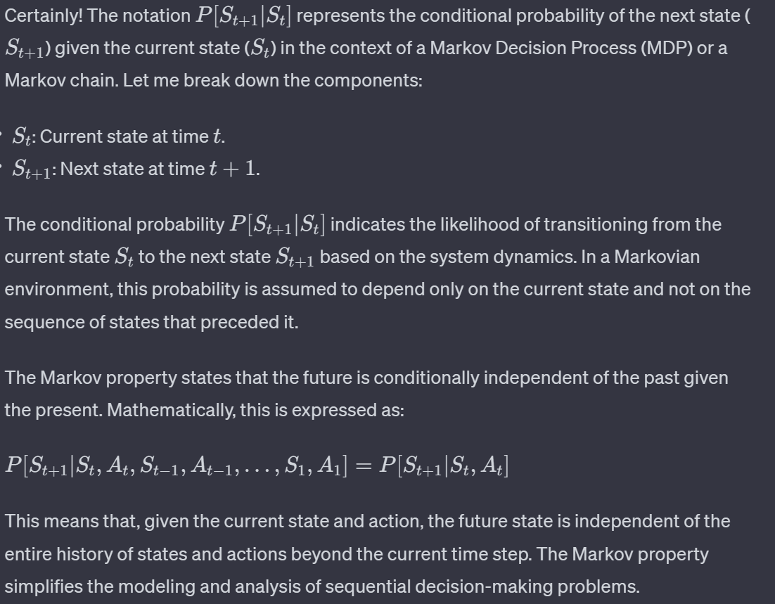

In traditional Q-learning, the Q-function is represented using a Q-table, where each entry corresponds to the expected cumulative reward for taking a specific action in a specific state. However, as the state space grows larger, maintaining and updating this table becomes impractical and computationally expensive. Neural networks are introduced in Q-learning to address the limitations of Q-tables, particularly when dealing with high-dimensional or continuous state spaces. The combination of Q-learning with neural networks results in what is known as Deep Q-Networks (DQN).

Where do we use neural networks in Q-learning and why are they needed?
Here's how neural networks are used in Q-learning and the reasons for their introduction:
1. Function Approximation:
- Challenge: Traditional Q-learning struggles with large or continuous state spaces because it requires storing and updating a Q-table, which becomes infeasible when the state space is too large.
- Solution: Neural networks are used to approximate the Q-function. Instead of maintaining a table, the Q-values are estimated using a neural network that takes the state as input and outputs Q-values for each action.
2. Continuous and High-Dimensional State Spaces:
- Challenge: In problems with continuous or high-dimensional state spaces (e.g., images in computer vision tasks), discretizing the state space for a Q-table is not practical.
- Solution: Neural networks can handle continuous and high-dimensional inputs, making it feasible to learn Q-functions for such environments.
3. Generalization:
- Challenge: Traditional Q-tables might require an entry for every possible state-action pair, which lacks generalization.
- Solution: Neural networks generalize across similar states, learning to estimate Q-values for unseen states based on their similarities to states encountered during training.
4. Memory Efficiency:
- Challenge: Q-tables can be memory-intensive, especially when dealing with large state spaces.
- Solution: Neural networks provide a more memory-efficient way to represent the Q-function by parameterizing the Q-values with the weights of the network.
5. Experience Replay:
- Challenge: Sequential updates to the Q-function can lead to instability and divergence during training.
- Solution: Neural networks are used in conjunction with experience replay, where past experiences (state, action, reward, next state) are stored in a replay buffer. During training, random batches of experiences are sampled from the buffer to decorrelate updates and improve stability.
6. Deep Q-Networks (DQN):
- Challenge: Learning a Q-function with a neural network introduces challenges such as instability and divergence.
- Solution: Techniques like target networks (separate networks for prediction and target) and loss functions designed to stabilize training are used in DQN to improve convergence.
In summary, neural networks are introduced in Q-learning to address scalability issues, handle continuous state spaces, enable generalization, and improve memory efficiency. They form the basis for powerful algorithms like Deep Q-Networks, allowing reinforcement learning to be applied to a wider range of complex problems.

Name one advantage and one disadvantage of Recurrent Neural Networks in general
Advantage:
- Temporal Dynamics: One of the significant advantages of Recurrent Neural Networks (RNNs) is their ability to capture temporal dynamics and sequential dependencies in data. RNNs have a memory element that allows them to maintain information about past inputs, making them well-suited for tasks where the order of input data is crucial, such as time series analysis, natural language processing (NLP), and speech recognition.
Disadvantage:
- Difficulty with Long-Term Dependencies: A notable disadvantage of traditional RNNs is their difficulty in learning and retaining information from long sequences. As the sequence length increases, RNNs often face challenges in effectively capturing dependencies that are separated by long intervals. This issue is known as the "vanishing gradient problem" or "exploding gradient problem," where gradients either become too small or too large during backpropagation, hindering learning.
While these disadvantages led to the development of more advanced recurrent architectures like Long Short-Term Memory (LSTM) networks and Gated Recurrent Units (GRUs), it's essential to acknowledge that traditional RNNs may still struggle with long-term dependencies without additional mechanisms or architectural modifications.

Long-Short Term Memory Units suffer less from the vanishing gradient problem than vanilla RNNs. What two design changes make this possible?
Long Short-Term Memory (LSTM) units were specifically designed to address the vanishing gradient problem that affects vanilla Recurrent Neural Networks (RNNs). Two key design changes in LSTM units contribute to mitigating the vanishing gradient problem:

1. Introduction of Memory Cells:
- In LSTM units, the concept of memory cells is introduced to store and retrieve information over long sequences. The memory cell serves as a persistent storage unit that can capture long-term dependencies in the input sequence.
- The memory cell is regulated by three gates: the input gate ((i)), the forget gate ((f)), and the output gate ((o)). These gates control the flow of information into, out of, and within the memory cell.
- The forget gate allows the LSTM to selectively erase information from the cell, preventing unnecessary or outdated information from persisting over time.
2. Use of Gating Mechanisms:
- LSTM units incorporate gating mechanisms to control the flow of information through the network. These gates are trainable and enable the LSTM to decide which information to keep or discard.
- The forget gate ((f)) decides which information from the previous cell state should be discarded.
- The input gate ((i)) determines which new information from the current input should be stored in the memory cell.
- The output gate ((o)) regulates the information that is output from the memory cell to the next hidden state.

By incorporating these design changes, LSTM units can selectively retain and update information over long sequences, making them less susceptible to the vanishing gradient problem compared to traditional RNNs. The gating mechanisms and memory cells allow LSTMs to capture and propagate relevant information over extended periods, making them more effective for tasks involving long-term dependencies in sequential data.
- Gate system, especially the forget gate
- Highway for gradients through the cell state

You are tasked to predict house prices for your first job, i.e. for a given input vector of numbers you have to predict a single floating point number that indicates the house price (e.g., between 0 and 1m euros).
For a house price prediction problem, where the task is to predict a continuous numeric value (house price), the choice of a suitable loss function is crucial. Here are a couple of commonly used loss functions for regression problems like this:
1. Mean Squared Error (MSE):
- Loss Function: ( text{MSE} = frac{1}{N} sum_{i=1}^{N} (y_i - hat{y}_i)^2 )
- Explanation: MSE is a widely used loss function for regression problems. It penalizes the model more severely for larger prediction errors. Squaring the differences between the true ((y_i)) and predicted ((hat{y}_i)) values ensures that both overestimations and underestimations contribute to the loss in a symmetric manner.
2. Mean Absolute Error (MAE):
- Loss Function: ( text{MAE} = frac{1}{N} sum_{i=1}^{N} |y_i - hat{y}_i| )
- Explanation: MAE is an alternative to MSE and measures the average absolute difference between the true and predicted values. It is less sensitive to outliers compared to MSE and provides a more robust measure of prediction accuracy.
The choice between MSE and MAE often depends on the specific characteristics of your dataset and the problem at hand:
- MSE is more sensitive to outliers: If your dataset contains outliers (extreme values), MSE may be influenced more by these outliers compared to MAE. If outliers are a concern, MAE might be a more suitable choice.
- Robustness to outliers: MAE is generally considered a more robust metric when dealing with datasets that may have noisy or outlier-rich samples.
- Differentiable property: Both MSE and MAE are differentiable, making them suitable for gradient-based optimization algorithms commonly used in training neural networks.
In practice, it's a good idea to try both MSE and MAE during the model development phase and see how they perform on your specific dataset. You can choose the one that aligns better with your evaluation criteria and the characteristics of the data.
In the context of machine learning, "floating-point regression" typically refers to regression tasks where the target variable (the variable to be predicted) is a continuous, real-valued number represented as a floating-point number. Floating-point numbers are used to approximate real numbers and are commonly employed in tasks such as predicting house prices, stock prices, temperature, or any other continuous quantity.
The Mean Squared Error (MSE) loss is a common choice for floating-point regression tasks. In the context of regression, the MSE loss is calculated by taking the mean of the squared differences between the predicted values and the true values.
To approximate a regression task as a classification problem, you would need to discretize the continuous target variable (house prices) into different classes or bins. This process is often referred to as binning or bucketing. Once the continuous values are discretized into classes, you can then treat the problem as a multi-class classification task.
Choose a suitable classification loss function. For multi-class classification problems, commonly used loss function is Cross-Entropy Loss (Categorical Cross-Entropy).

Why can’t we expect to find a global minima while training neural networks?
The inability to guarantee finding a global minimum during the training of neural networks is primarily attributed to the highly non-convex nature of the loss landscape in the high-dimensional parameter space. Several factors contribute to the challenges of locating a global minimum in neural network optimization:
Non-Convexity:
The loss function of neural networks is highly non-convex due to the composition of multiple non-linear activation functions and the intricate interactions among weights and biases. In a non-convex landscape, there are numerous local minima, saddle points, and plateaus that make the optimization problem complex.
High-Dimensionality:
Neural networks often have a large number of parameters, leading to a high-dimensional optimization space. The presence of many dimensions increases the likelihood of encountering multiple local minima, making it challenging to explore the entire space thoroughly.
Symmetry and Permutations:
Many neural network architectures exhibit symmetries and parameter permutations, where different weight configurations may lead to the same function. This results in multiple equivalent solutions, and optimization algorithms may converge to any of these solutions.
Noise and Stochasticity:
Training neural networks involves the use of stochastic optimization algorithms, such as stochastic gradient descent (SGD) or variants. The inherent noise introduced by mini-batch sampling and other stochastic elements can cause the optimization process to escape from certain regions and affect convergence to a global minimum.
Ill-Conditioning:
The loss landscape may be ill-conditioned, with regions of very steep and very shallow gradients. This can lead to slow convergence, and the optimization algorithm may struggle to navigate effectively in such landscapes.
Saddle Points:
Saddle points, which are critical points where the gradient is zero but the point is neither a minimum nor a maximum, are prevalent in high-dimensional spaces. Optimization algorithms can get stuck at saddle points, leading to suboptimal convergence.
Despite these challenges, it's important to note that finding a global minimum may not be necessary for achieving good generalization and performance in practice. Neural networks are often overparameterized, and many different parameter configurations can lead to similar performance. Moreover, successful training can be achieved by reaching a sufficiently low value of the loss function, even if the optimization process doesn't converge to a global minimum. Techniques such as random initialization, learning rate schedules, and the use of regularization methods contribute to successful training and model generalization.

Why is finding a local minimum often enough?
In the context of training neural networks, finding a local minimum in the loss landscape is often sufficient for achieving good model performance.
Overparameterization:
Neural networks are often overparameterized, meaning there are more parameters than needed to represent the underlying function. This overparameterization can lead to multiple equivalent solutions, with different parameter configurations yielding similar performance.

What is a saddle point? What is the advantage/disadvantage of Stochastic Gradient Descent (SGD) in dealing with saddle points?
Saddle Point:
A saddle point is a critical point in the optimization landscape of a function where the gradient is zero, but the point is neither a minimum nor a maximum. At a saddle point, the surface curves upwards in some dimensions and downwards in others, resembling the shape of a saddle. Unlike a local minimum or maximum, a saddle point is a point of inflection where the function neither reaches a peak nor a trough.
In the context of optimization problems, such as those encountered in training neural networks, saddle points can pose challenges for optimization algorithms.
Advantage/Disadvantage of Stochastic Gradient Descent (SGD) in Dealing with Saddle Points:
Advantage:
- Escape from Saddle Points: Stochastic Gradient Descent (SGD) has a stochastic element due to the use of mini-batches, which introduces noise into the optimization process. This stochasticity enables SGD to escape from saddle points more effectively than deterministic gradient descent methods. The noisy updates from mini-batch gradients can provide the necessary perturbation to move away from the saddle point and continue the optimization process.
Disadvantage:
- Lack of Momentum: Traditional SGD lacks momentum, which can slow down convergence in certain situations. Momentum techniques, such as those used in variants like SGD with Momentum or Adam, address this limitation by incorporating a moving average of past gradients.
In summary, the advantage of SGD in dealing with saddle points lies in its ability to escape from them due to the stochasticity introduced by mini-batch sampling. However, the disadvantage is that the stochastic nature of SGD can lead to slower convergence, and careful tuning of learning rates or the use of adaptive learning rate methods may be necessary to address this issue.

Explain the concept behind momentum in SGD
Avoid getting stuck in local minima. or accelerate optimization. Uses exponentially weighted averages of past gradients.
Momentum is a technique used in Stochastic Gradient Descent (SGD) and its variants to accelerate the convergence of the optimization process. The concept of momentum is inspired by the physical analogy of a ball rolling down a hill, gaining momentum as it moves. In the context of optimization, momentum helps the optimization algorithm to continue moving in the same direction as the previous updates, thereby smoothing out oscillations and speeding up convergence.
Smoothing Effect:
The momentum term introduces a smoothing effect. When the gradients have consistent directions across iterations, the velocity term accumulates and amplifies these consistent updates, leading to faster convergence.
When the gradients change direction or oscillate, the accumulated momentum helps the optimization process to carry through these fluctuations, preventing rapid changes in the optimization trajectory.
Benefits:
Momentum helps overcome the challenge of oscillations or slow convergence in certain situations, especially in the presence of noisy gradients or along elongated, curved loss surfaces.
It accelerates the optimization process in the direction of consistent gradients, facilitating faster convergence.
Damping Oscillations:
Momentum acts as a damping factor for oscillations, preventing the optimization process from changing direction abruptly. This can be particularly beneficial in scenarios where the loss landscape is characterized by plateaus, valleys, or other complex structures.

Which optimizer introduced in the lecture uses second but not first order momentum?
Optimizers that use only second-order information (specifically, second moments of the gradients) and do not incorporate first-order momentum are less common. However, one such optimizer is the RMSprop (Root Mean Square Propagation) optimizer.
In RMSprop, the second-order moment (squared gradient) is accumulated, similar to Adagrad, but with a modification to address the issue of rapidly decreasing learning rates.
In contrast to Adagrad, RMSprop uses an exponentially decaying average of squared gradients rather than an accumulated sum. This modification helps prevent the learning rates from becoming too small over time, making RMSprop more suitable for non-stationary optimization problems.
While RMSprop is not as widely used as some other optimizers like Adam, it is an example of an optimizer that leverages second-order information without incorporating first-order momentum. Keep in mind that the field of optimization algorithms is dynamic, and newer variants or combinations of techniques may emerge over time.

Explain the beta (beta_1 and beta_2) hyperparameters of Adam with respect to the gradients
In the context of the Adam optimizer, the hyperparameters beta_1 and beta_2 are used to control the exponential decay rates of the first-order moment (mean) and the second-order moment (uncentered variance) of the gradients, respectively.
Instead of adapting the parameter learning rates based on the average first moment (the mean) as in RMSProp, Adam also makes use of the average of the second moments of the gradients (the uncentered variance).
Specifically, the algorithm calculates an exponential moving average of the gradient and the squared gradient, and the parameters beta1 and beta2 control the decay rates of these moving averages.
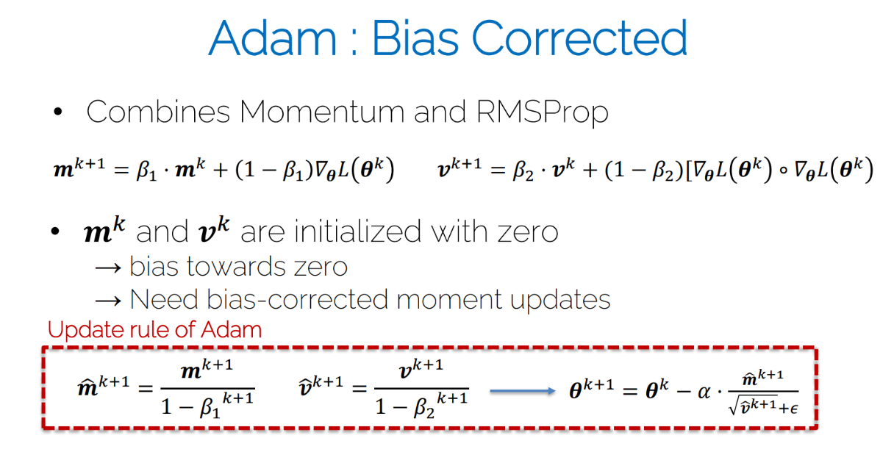

What would be an advantage of a second order optimization method such as the Newton method? Why is it not commonly used in the context of neural networks?
Advantage of Second-Order Optimization Method:
An advantage of second-order optimization methods, such as the Newton's method, is that they can provide more information about the local curvature of the optimization landscape. Specifically:
- Faster Convergence: Second-order methods take into account not only the gradient (first-order information) but also the curvature of the loss function. This additional information allows them to navigate the optimization landscape more efficiently and converge to the optimum in fewer iterations compared to first-order methods.
Why Not Commonly Used in Neural Networks:
While second-order optimization methods have certain advantages, they are not commonly used in the context of neural networks for several reasons:
- Computational Complexity: Computing and storing the Hessian matrix (second-order derivative of the loss function) is computationally expensive, especially in high-dimensional spaces with many parameters. The Hessian matrix has (O(n^2)) elements, where (n) is the number of parameters. In neural networks with millions or billions of parameters, this becomes impractical.
- Memory Requirements: Storing the entire Hessian matrix requires a significant amount of memory, and its inversion is computationally expensive. This poses challenges for training large neural networks, where memory resources are often a limiting factor.
- Non-Convexity and Ill-Conditioning: The loss landscape of neural networks is highly non-convex and can be ill-conditioned. Second-order methods may encounter difficulties in dealing with saddle points, high curvature regions, and other complex structures in the optimization landscape.
- Noise Sensitivity: In the presence of noisy or stochastic gradients (common in deep learning), the Hessian matrix estimation can be sensitive to noise, leading to inaccurate curvature information.
- Adaptability: First-order methods with adaptive learning rates (e.g., Adam, Adagrad) have shown good adaptability and performance in a variety of neural network architectures and tasks. These methods can efficiently handle the non-convex and high-dimensional nature of neural network optimization.
Due to these practical challenges, the computational cost, memory requirements, and the adaptability of second-order methods make them less suitable for training deep neural networks. Instead, first-order optimization algorithms with adaptive learning rates and other enhancements (e.g., Adam, RMSprop) have become more prevalent in the field of deep learning.

Name the key idea of Newton’s method and write down the update step formula
Approximate by second order Taylor expansion
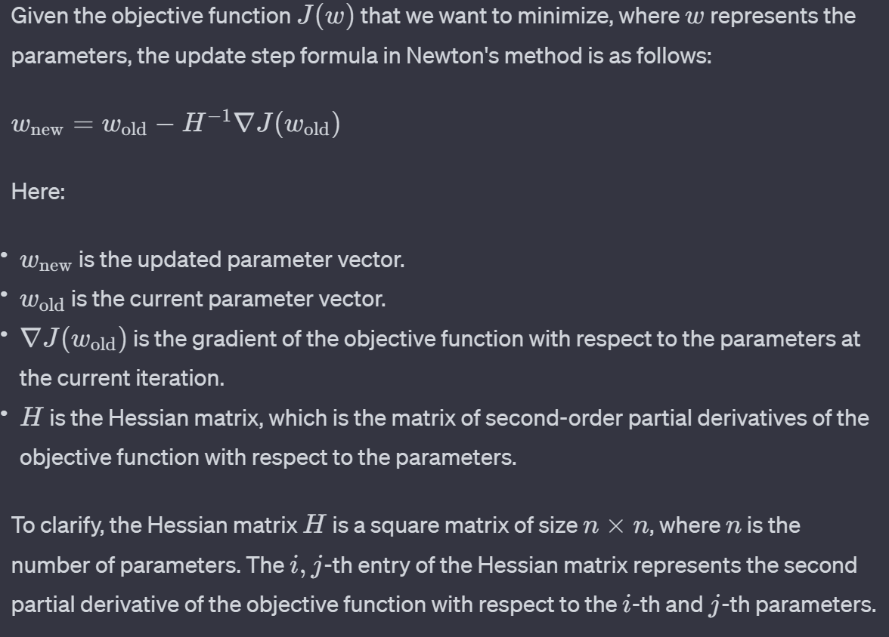
The key idea of Newton's method is to use second-order information (specifically, the Hessian matrix) in addition to the gradient to iteratively update the parameters during optimization. Newton's method aims to find the roots of the first-order derivative (gradient) by considering the second-order derivative (Hessian) information. This enables more direct and rapid convergence toward the minimum of the function.

In practice, the inverse of the Hessian matrix (H^-1) is computationally expensive to compute and may be ill-conditioned, especially in high-dimensional spaces. Therefore, practical implementations often use approximations or variants of Newton's method, such as the limited-memory Broyden-Fletcher-Goldfarb-Shanno (L-BFGS) algorithm, which approximates the inverse Hessian without explicitly computing it.

What is the purpose of activation functions in neural networks?
Activation functions play a crucial role in neural networks by introducing non-linearity into the network. The primary purpose of activation functions is to determine the output of a neural network, specifically for each neuron or node in the network.
Here are some key purposes of activation functions:
1. Introducing Non-linearity: Activation functions introduce non-linearities to the network, allowing the neural network to learn from and approximate complex, non-linear relationships in data. Without non-linear activation functions, a neural network would essentially reduce to a linear model, and multiple layers of linear transformations would not provide any significant advantage.
2. Enabling Complex Representations: Non-linear activation functions allow neural networks to learn and represent complex mappings from inputs to outputs. This is crucial for solving problems that involve intricate patterns and relationships in the data.
3. Supporting Gradient Descent: Activation functions are essential for the backpropagation algorithm, which is used to train neural networks. During backpropagation, the gradient of the loss function with respect to the weights is calculated and used to update the weights. Non-linear activation functions ensure that the network's error can be backpropagated effectively through the layers.
4. Thresholding and Output Range: Activation functions can also be designed to threshold the output at a certain level, such as the step function. Additionally, they can be scaled to specific output ranges, like the sigmoid function outputs values between 0 and 1, making it suitable for binary classification problems.
Commonly used activation functions include:
- Sigmoid: Outputs values between 0 and 1, commonly used in the output layer of binary classification models.
- Hyperbolic Tangent (tanh): Similar to sigmoid but outputs values between -1 and 1, which can be beneficial for centering data.
- Rectified Linear Unit (ReLU): Outputs the input for positive values and zero for negative values. It has become a popular choice due to its simplicity and effectiveness in training deep neural networks.
- Softmax: Used in the output layer for multi-class classification problems, as it converts a vector of real numbers into a probability distribution.
The choice of activation function depends on the specific problem and characteristics of the data being used.

You find that your network still is not training properly and discover that your network weights have all been default initialized to 1. Why might this cause issues for training?
Initializing all network weights to the same value, such as 1, can lead to several issues during training. This phenomenon is known as the "symmetry problem," and it can hinder the learning process in neural networks. Here are some reasons why this can be problematic:
1. Symmetry Breaking: When all weights are initialized to the same value, all neurons in a given layer will produce the same output during forward propagation. This symmetry leads to symmetric weight updates during backpropagation, and the model fails to learn different features or representations. In other words, the neurons in a layer become interchangeable and learn the same patterns, limiting the capacity of the network to capture diverse features.
2. Vanishing Gradients: During backpropagation, the gradient of the loss with respect to the weights is calculated. If all weights are the same, the gradients will also be the same, causing the updates to be uniform. This can result in vanishing gradients, especially for deep networks, where the gradient signal diminishes as it is propagated backward through layers. Vanishing gradients make it challenging for the network to adjust the weights effectively, leading to slow or stalled learning.
3. Limited Capacity: Neural networks derive their power from the ability to learn diverse and hierarchical representations. If all neurons in a layer behave the same way due to identical weights, the network's capacity to model complex relationships is severely limited.
To address these issues, it is common practice to initialize weights with small random values using techniques such as Gaussian or uniform distributions. This helps break the symmetry and ensures that neurons in the network start with different initial states, facilitating diverse learning. Popular weight initialization methods include He initialization (used with ReLU) and Xavier/Glorot initialization, which are designed to balance the scale of weights based on the number of input and output connections to each neuron.
In summary, initializing all network weights to the same value disrupts the learning dynamics of neural networks, causing symmetry and vanishing gradient problems. Weight initialization methods that introduce diversity among neuron activations are crucial for proper training and convergence.

How can you resolve the problems with weight initialization and provide stable training in most scenarios for the proposed network? Explain your solution.
To address the problems associated with weight initialization and ensure stable training, it's important to use appropriate weight initialization techniques. Here are some commonly used methods to achieve stable training in neural networks:
Xavier/Glorot initialization is designed to address the vanishing/exploding gradient problem by initializing weights based on the number of input and output connections to a neuron.
For a layer with input units and output units, the weights are initialized from a Gaussian distribution with mean 0 and variance​.
He initialization is specifically designed for networks using ReLU activation functions, addressing the issue of dead neurons that may occur with Xavier/Glorot initialization.
Xavier / Kaiming initialization; aims to maintain same variance of output as input.

After employing your solutions, you are ready to train your network for image segmentation. After 50 epochs, you come to the conclusion that the network is too large for such a task. What is this effect called? How do you make this observation? Without changing the convolutional layers of your network, name two approaches to counteract the problems encountered.
The effect you're describing is known as overfitting. Overfitting occurs when a machine learning model, such as your neural network, learns the training data too well, capturing noise or random fluctuations in the data rather than the underlying patterns. As a result, the model performs well on the training set but fails to generalize effectively to new, unseen data.
You can make the observation of overfitting by monitoring the performance of your model on both the training set and a separate validation set during training. The following scenarios may indicate overfitting:
1. High Training Accuracy, Low Validation Accuracy:
- The model achieves a high accuracy on the training data but a significantly lower accuracy on the validation data. This indicates that the model is memorizing the training data rather than learning the underlying patterns.
2. Increasing Gap Between Training and Validation Loss:
- As training progresses, if you observe a widening gap between the training loss and the validation loss, it suggests that the model is fitting the training data too closely, and its ability to generalize is diminishing.
3. Performance Plateau on Validation Set:
- If the validation performance plateaus or starts to degrade while the training performance continues to improve, it indicates that the model is becoming too complex and is overfitting the training data.
To address overfitting and make the network more suitable for the image segmentation task, you can consider the following techniques:
1. Reduce Model Complexity:
- If the network is too large, consider reducing the number of layers or the number of neurons in each layer. This can help prevent the model from capturing noise in the training data.
2. Regularization Techniques:
- Apply regularization techniques such as dropout, which randomly drops out some neurons during training, or L1/L2 regularization, which adds penalties to the weights to prevent them from becoming too large.
3. Data Augmentation:
- Increase the diversity of your training data by applying data augmentation techniques. This can involve random rotations, flips, scaling, or other transformations to create variations of the input images.
4. Early Stopping:
- Monitor the validation performance during training and stop training when the validation performance starts to degrade. This prevents the model from overfitting by halting training before it becomes too specialized to the training set.
By carefully tuning the model architecture, applying regularization, and monitoring performance, you can mitigate overfitting and build a more robust model for image segmentation.
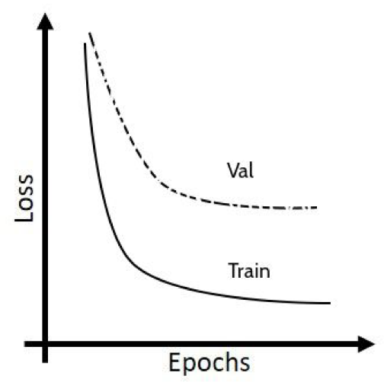

Name the main difference of Batch normalization during training or testing and note down eventual parameters that need to be stored
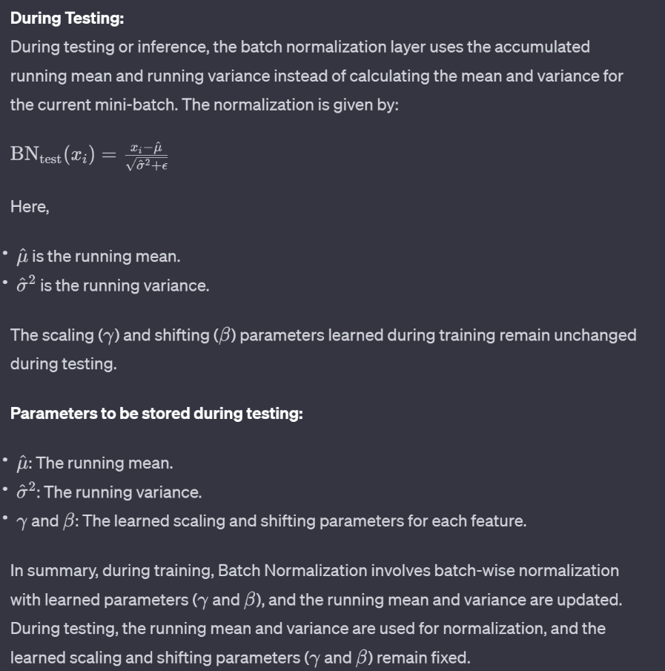
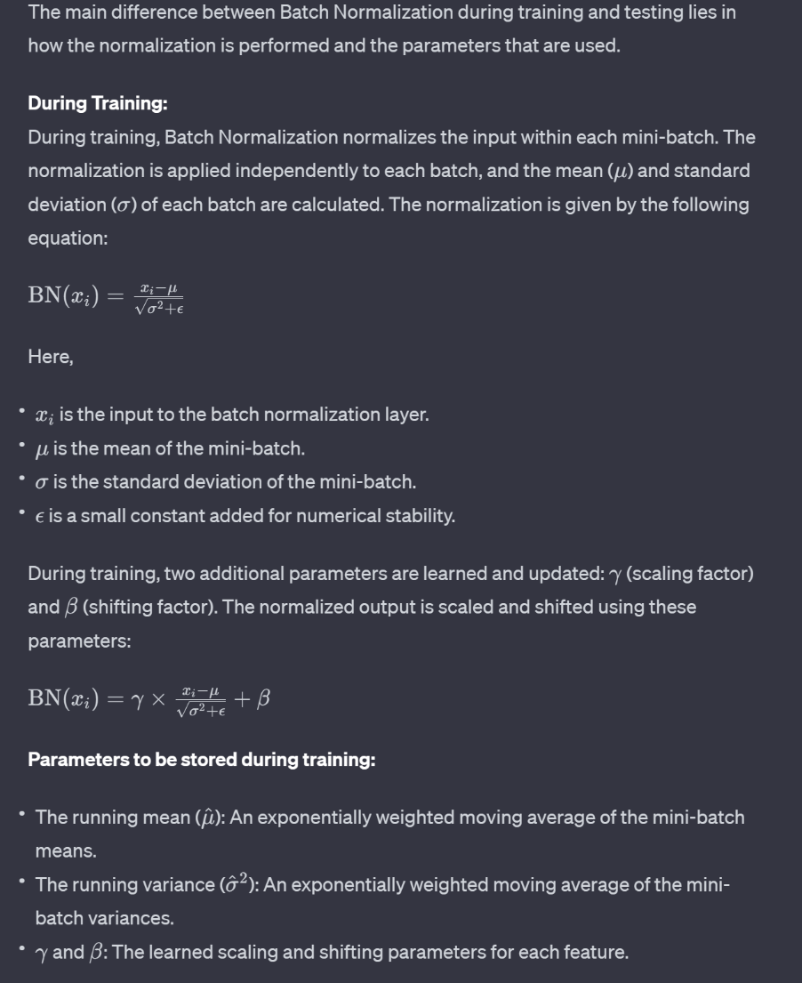

Train: Compute statistics from minibatch. To store: mean and variance. Calculate the mean and variance computed from the mini-batch and store a weighted average across training mini-batches for the update at test time.
Test: use stored mean and variance and don’t compute any batch statistics. Use exponentially weighted / moving / running average mean and variance that was computed at training time on the test samples.

Global Average Pooling
Certainly! Let's delve into more detail about the concept of Global Average Pooling (GAP) and how it contributes to creating a fixed-size output regardless of the input size.
In a traditional convolutional neural network (CNN) architecture, after several convolutional and pooling layers, the spatial dimensions of the feature maps are typically reduced, leading to a 3D tensor with dimensions (height, width, channels). Traditional fully connected layers are then applied to flatten these 3D tensors into a vector for final classification.
Global Average Pooling offers an alternative to this flattening step. Instead of flattening the entire feature map into a vector, it computes the average of each channel (feature) independently across the entire spatial dimensions.
Here's how it works:
1. Spatial Dimensions:
- After the convolutional and pooling layers, the feature map has spatial dimensions (height, width, channels).
2. Global Average Pooling:
- For each channel, the average value across the entire spatial dimensions is computed. This is done independently for each channel.
- The result is a single value for each channel.
3. Output:
- The output of the Global Average Pooling layer is a fixed-size tensor with dimensions (1, 1, channels). The height and width dimensions collapse to 1, and you have a single value per channel.
Benefits:
1. Fixed Output Size:
- The key advantage of Global Average Pooling is that it produces a fixed-size output regardless of the input size. This is particularly useful when dealing with variable-sized input images.
2. Reduces Overfitting:
- By summarizing the information in each channel with a single value, Global Average Pooling acts as a form of regularization. It reduces the number of parameters in the model, making it less prone to overfitting.
3. Spatial Invariance:
- Global Average Pooling introduces a degree of spatial invariance. The model becomes less sensitive to the precise location of features within the spatial dimensions.
This layer is often used as the final layer before the output layer in architectures that prioritize spatial adaptability and regularization.
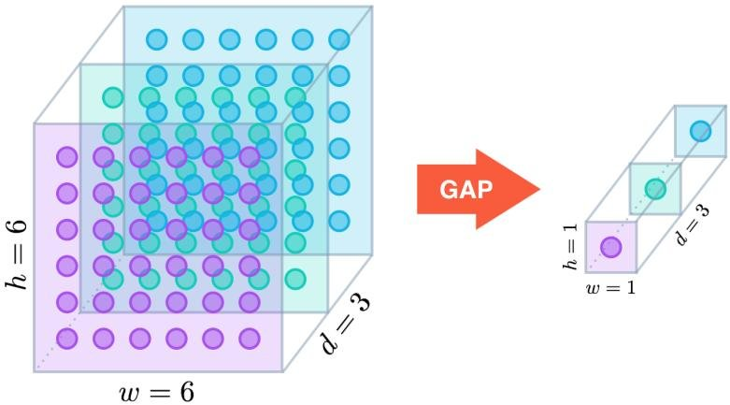

You decide to try out a much deeper network to boost the network’s capacity. Name 2 problems that you might encounter when training very deep networks
When training very deep neural networks, especially in the context of convolutional neural networks (CNNs) or deep feedforward neural networks, there are two common problems that can be encountered:
1. Vanishing Gradients:
- As the network becomes deeper, the gradients during backpropagation can diminish exponentially as they are propagated backward through the layers. This phenomenon is known as vanishing gradients. When gradients become very small, the weights of the earlier layers receive very little or no updates during training. As a result, these layers may not effectively learn meaningful representations, hindering the overall training process.
2. Exploding Gradients:
- On the contrary, exploding gradients refer to the situation where the gradients grow exponentially as they are propagated backward through the layers. This can lead to extremely large weight updates, causing the model to diverge during training. The optimization process becomes unstable, and the model fails to converge to a meaningful solution.
3. Overfitting:
- Another significant challenge when training very deep neural networks, and it can be exacerbated by the increased model capacity that comes with deeper architectures. Overfitting occurs when a model learns not only the underlying patterns in the training data but also the noise and specificities of that particular dataset. As a result, the model performs well on the training data but fails to generalize to new, unseen data.
Addressing these issues is crucial for successfully training deep networks. Here are some strategies to mitigate these problems:
- Weight Initialization:
- Careful choice of weight initialization methods can help alleviate the vanishing and exploding gradient problems. Techniques like He initialization for ReLU activations and Xavier/Glorot initialization for tanh and sigmoid activations are commonly used.
- Batch Normalization:
- Batch normalization can stabilize training by normalizing the inputs to each layer. It helps in mitigating the internal covariate shift and can contribute to addressing the vanishing gradient problem.
- Skip Connections (Residual Networks):
- Introducing skip connections, as seen in residual networks (ResNets), allows the gradient to flow more easily through the network. The idea is to add shortcut connections that bypass one or more layers, facilitating the flow of gradients during backpropagation.
- Gradient Clipping:
- Gradient clipping involves capping the gradients during training to prevent them from becoming too large. This can be an effective technique to mitigate exploding gradients.
- Proper Architecture Design:
- Designing the network architecture carefully, including the use of appropriate activation functions, regularization techniques, and architectural elements, can contribute to smoother training of deep networks.
- Use of Different Architectures:
- Architectures designed specifically to address the challenges of deep learning, such as attention mechanisms or transformer architectures, can be explored to mitigate gradient-related issues.
By employing these strategies, researchers and practitioners aim to build and train deep neural networks that can effectively capture complex patterns and representations in the data.

Vanishing Gradients Problem
Activation functions, such as sigmoid and hyperbolic tangent (tanh), are responsible for introducing non-linearity into the DNN model. However, these functions suffer from the saturation problem, where the gradients become close to zero for large or small inputs, contributing to the vanishing gradient problem. Backpropagation, which computes the gradients of the loss function with respect to the weights in a chain rule fashion, exacerbates the problem by multiplying these small gradients.
The rectified linear unit (ReLU) activation function helps overcome the vanishing gradient problem by avoiding gradient saturation. ReLU replaces negative values with zero, ensuring that the gradients flowing backward remain non-zero and do not vanish. This promotes better gradient flow and enables effective learning in deep neural networks.

Linear regression and logistic regression
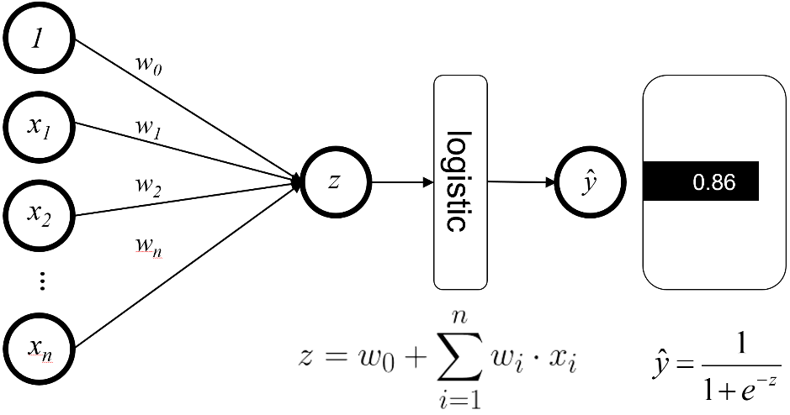
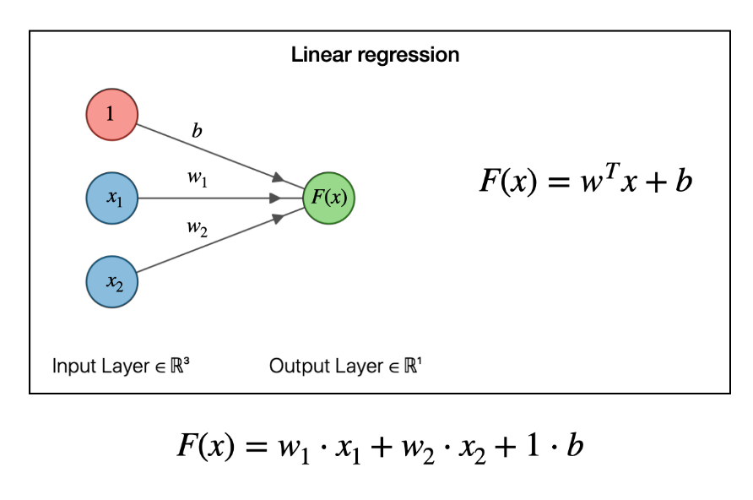
Linear regression and logistic regression are both widely used statistical techniques, but they serve different purposes and are applicable in distinct scenarios. Here's a comparison between linear and logistic regression:
1. Nature of the Dependent Variable:
- Linear Regression:
- Dependent Variable: Continuous (numeric) variable.
- Example: Predicting house prices, temperature, sales revenue, etc.
- Logistic Regression:
- Dependent Variable: Binary categorical variable (typically 0 or 1).
- Example: Predicting whether an email is spam or not, customer churn (yes or no), etc.
2. Output Range:
- Linear Regression:
- Output Range: The predicted values can range from negative infinity to positive infinity.
- Logistic Regression:
- Output Range: The predicted values are transformed using the sigmoid function, yielding probabilities between 0 and 1.
3. Equation:
- Linear Regression:
- Equation: y = b_0 + b_1x_1 + b_2x_2 + \ldots + b_nx_n, where y is the dependent variable, b_0 is the intercept, and b_1, b_2, \ldots, b_n are coefficients.
- Logistic Regression:
- Equation: p = \frac{1}{1 + e^{-(b_0 + b_1x_1 + b_2x_2 + \ldots + b_nx_n)}}, where p is the probability of the event happening.
4. Purpose:
- Linear Regression:
- Purpose: Used for predicting a continuous outcome.
- Example: Predicting house prices, stock prices, etc.
- Logistic Regression:
- Purpose: Used for binary classification problems.
- Example: Predicting whether an email is spam, whether a customer will churn, etc.
5. Loss Function:
- Linear Regression:
- Loss Function: Typically uses mean squared error (MSE) as the loss function.
- Logistic Regression:
- Loss Function: Uses binary cross-entropy (log loss) as the loss function.
6. Interpretability:
- Linear Regression:
- Interpretability: Coefficients represent the change in the dependent variable for a one-unit change in the corresponding independent variable.
- Logistic Regression:
- Interpretability: Coefficients represent the change in the log-odds of the event happening for a one-unit change in the corresponding independent variable.
7. Assumptions:
- Linear Regression:
- Assumptions: Assumes a linear relationship between the independent and dependent variables, homoscedasticity, independence of errors, etc.
- Logistic Regression:
- Assumptions: Assumes a logistic (S-shaped) relationship between the independent variables and the log-odds of the dependent variable.
8. Application:
- Linear Regression:
- Application: Used in scenarios where the outcome variable is continuous and can take any real value.
- Logistic Regression:
- Application: Used when the outcome variable is categorical (binary) and involves predicting the probability of an event.
In summary, while linear regression is suited for predicting continuous outcomes, logistic regression is specifically designed for binary classification problems where the outcome is categorical. Each has its own set of assumptions, equations, and interpretation methods that align with the nature of the data they are meant to analyze.

Too small and too big variances in weight initialization
Too small variance: The output in deeper layers is close to zero. Therefore, the gradient w.r.t the weights also becomes very small (vanishing gradient).
Too large variance: The tanh activation function saturates. Therefore, the gradient w.r.t the weights becomes very small (vanishing gradient).

Batch Normalization
Batch Normalization (BN) is a technique used in neural networks to improve training stability and speed up convergence. It has several advantages and is applied for the following reasons:
1. Mitigating Internal Covariate Shift:
- Internal Covariate Shift refers to the change in the distribution of the network's activations during training. This can make training difficult because the parameters of the network need to adapt to the changing input distributions.
- Batch Normalization normalizes the inputs of each layer by centering and scaling them, reducing internal covariate shift and stabilizing the training process.
2. Accelerating Training Convergence:
- Batch Normalization often leads to faster convergence during training. By maintaining a more consistent input distribution to each layer, the optimization process can converge more quickly, reducing the number of training epochs needed.
3. Reducing Sensitivity to Initialization:
- Batch Normalization makes neural networks less sensitive to the choice of initial weights. This is beneficial because it allows for the use of higher learning rates and can speed up convergence during the early stages of training.
4. Mitigating the Vanishing and Exploding Gradient Problems:
- Batch Normalization helps address issues related to vanishing or exploding gradients during backpropagation. By normalizing the inputs to each layer, BN can prevent extreme values that might cause gradient-related problems.
5. Enabling Higher Learning Rates:
- Batch Normalization allows for the use of higher learning rates without the risk of divergence. This is because it can handle variations in input distributions and stabilize the training process.
6. Regularization Effect:
- Batch Normalization acts as a form of regularization by introducing noise during training. This has a similar effect to dropout, which can help prevent overfitting.
7. Applicability to Various Network Architectures:
- Batch Normalization is versatile and can be applied to various types of neural network architectures, including feedforward networks, convolutional neural networks (CNNs), and recurrent neural networks (RNNs).
8. Improved Generalization:
- Batch Normalization often leads to improved generalization performance on unseen data. By normalizing inputs, the network becomes less sensitive to variations in the input distribution, which can be particularly useful in situations with limited data.
It's important to note that while Batch Normalization is widely used and beneficial in many cases, it may not always be necessary or optimal for every type of network or application. Its effectiveness can depend on the specific characteristics of the data and the architecture of the neural network.

Covariate shift
Covariate shift is a situation in which the distribution of the model’s input features in production changes compared to what the model has seen during training and validation.
The term "Internal Covariate Shift" refers to the change in the distribution of the network's activations (outputs of neurons) as it goes through different layers during training. In simpler terms, it describes the shift in the statistical properties of the inputs to each layer as the network learns.

During the training of a neural network, the distribution of the input to each layer may change due to updates in the weights and biases during backpropagation.
Batch Normalization is a technique designed to address the issue of Internal Covariate Shift by normalizing the inputs of each layer. By centering and scaling the inputs, Batch Normalization helps maintain a more consistent distribution throughout the training process. This has the effect of stabilizing the training process, speeding up convergence, and making the network less sensitive to the choice of initial weights.

Gamma and Beta parameters in Batch Normalization
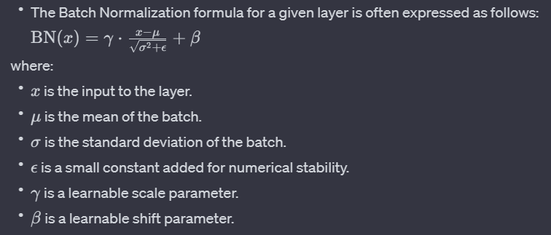
In the Batch Normalization (BN) formula, gamma and beta are learnable parameters introduced to provide the model with additional flexibility. These parameters allow the network to learn the optimal scaling and shifting of the normalized activations, introducing an adaptive element to the normalization process. Here's how gamma and beta are used in the BN formula:
2. Role of gamma and beta :
- Scaling gamma:
- The gamma parameter allows the network to scale (stretch or compress) the normalized activations. This enables the model to learn the optimal scaling for each feature, giving it the flexibility to adjust the magnitude of the activations based on what is most suitable for the task.
- Shifting beta:
- The beta parameter allows the network to shift the normalized activations. This introduces an additional bias term that can be learned. It provides the model with the flexibility to shift the normalized values, allowing for the recovery of some of the original representation if needed.
3. Learnability:
- Both gamma and beta are learnable parameters, meaning they are updated during the training process through backpropagation and optimization. This allows the model to adaptively adjust the scaling and shifting based on the characteristics of the data and the task at hand.
4. Adaptive Normalization:
- The inclusion of gamma and beta makes Batch Normalization more adaptive to the specific requirements of the data, and it allows the model to learn how to best normalize and transform the activations for improved training and generalization.
In summary, gamma and beta in the Batch Normalization formula introduce learnable parameters that enable the model to adaptively scale and shift the normalized activations. This adaptability helps in improving the training dynamics, stability, and the overall performance of the neural network.

How does an autoencoder as described above differ from linear methods to reduce the dimensionality of the data such as PCA?

An autoencoder built of neural networks (containing non-linearities) is a non-linear function.

Autoencoders and linear methods for dimensionality reduction, such as Principal Component Analysis (PCA), are both techniques used to reduce the dimensionality of data, but they differ in their approach and capabilities. Here are key differences between autoencoders and linear methods like PCA:
1. Linearity:
- PCA: PCA is a linear method, meaning it captures linear combinations of the input features to create new, orthogonal features (principal components). Each principal component is a weighted sum of the original features.
- Autoencoder: Autoencoders, particularly those with non-linear activation functions, can capture non-linear relationships in the data. The encoder-decoder architecture allows them to learn complex mappings between the input and lower-dimensional representations.
2. Representation Learning:
- PCA: PCA focuses on finding orthogonal directions (principal components) in the input space that capture the maximum variance.
- Autoencoder: Autoencoders learn representations that might not align with the original features. They are capable of learning more abstract and non-linear representations, capturing intricate patterns and relationships in the data.
3. Non-linear Transformations:
- PCA: PCA relies on linear transformations and orthogonal rotations to reduce dimensionality. It may not capture complex, non-linear relationships in the data as effectively.
- Autoencoder: Autoencoders can learn non-linear transformations through the use of activation functions in the encoder and decoder layers. This allows them to model more intricate patterns in the data.
4. Unsupervised Learning:
- PCA: PCA is an unsupervised technique that focuses on maximizing variance in the input data. It doesn't explicitly consider learning a mapping that reconstructs the original data.
- Autoencoder: Autoencoders are typically trained in an unsupervised manner to minimize the reconstruction error between the input and the reconstructed output. The learning process involves finding a compact representation that captures salient features.
5. Loss Function:
- PCA: PCA minimizes the mean squared reconstruction error, which is equivalent to maximizing the variance captured by the principal components.
- Autoencoder: Autoencoders commonly use a reconstruction loss, such as mean squared error or binary cross-entropy, to measure the dissimilarity between the input and reconstructed output. This encourages the model to learn a compressed representation.
6. Flexibility:
- PCA: PCA is limited to linear transformations and might not capture complex, non-linear patterns in the data.
- Autoencoder: Autoencoders are more flexible and can model non-linear relationships, making them suitable for capturing intricate structures in high-dimensional data.
In summary, while PCA is a linear technique focused on capturing variance in the data through orthogonal transformations, autoencoders are non-linear models capable of learning complex representations and capturing non-linear patterns in the data. The choice between them depends on the nature of the data and the complexity of the relationships you aim to model.

Size of the bottleneck in autoencoders
The size of the bottleneck or latent space in an autoencoder is a crucial hyperparameter that determines the dimensionality of the learned representation. Varying the size of the latent space can have significant implications for the performance and capabilities of the autoencoder. Here's a brief discussion of what may happen in two scenarios:
(i) Latent Space Is Too Small:
- Underfitting:
- If the latent space is too small, the autoencoder may struggle to capture the complexity and diversity of the input data. The compressed representation might lack the capacity to encode all the necessary information, leading to underfitting.
- Loss of Information:
- A small latent space may force the model to discard less important features or details in the input. This loss of information can result in a compressed representation that fails to faithfully reconstruct the original data.
- Reduced Expressiveness:
- The small latent space may limit the expressiveness of the model, making it challenging to represent intricate patterns and variations in the data. The model might prioritize preserving only the most salient features.
- Difficulty in Reconstruction:
- The reconstructed output may exhibit a significant loss of detail and fidelity compared to the original input. The autoencoder may struggle to reconstruct fine-grained structures and textures.
(ii) Latent Space Is Too Big:
- Overfitting:
- An excessively large latent space may lead to overfitting, where the autoencoder memorizes the training data instead of learning a meaningful representation. The model might capture noise or idiosyncrasies specific to the training set.
- High Dimensionality, Low Information:
- A large latent space might introduce redundancy and unnecessary complexity. The additional dimensions may not contribute significantly to the capture of meaningful information, resulting in a less efficient representation.
- Increased Computational Demands:
- Training and inference in a model with a large latent space can be computationally expensive. The increased number of parameters and computations may hinder the practicality and efficiency of the autoencoder.
- Reduced Generalization:
- A model with a large latent space may be less effective in generalizing to unseen data. The learned representation might be too specific to the training set, limiting the model's ability to adapt to diverse inputs.
Finding an Optimal Latent Space Size:
- The optimal size of the latent space depends on the complexity of the data and the specific requirements of the task.
- Hyperparameter tuning, cross-validation, and monitoring the reconstruction error on a validation set are common approaches to finding the right balance.
- Techniques like regularization (e.g., adding dropout) can be employed to prevent overfitting in larger latent spaces.
In summary, selecting an appropriate size for the latent space is a critical aspect of designing an autoencoder. It involves balancing the model's capacity to represent the data accurately with considerations of computational efficiency and generalization to new data.
(i) too small: loss of information/bad reconstruction quality/too much compression/extraction/blurry/ underfitting…
(ii) too big: too little compression/extraction/overfitting/poor generalization/learned identity mapping/ memorizes the inputs...

Generating new images with autoencoders
You are given a dataset containing 10,000 RGB images with height H and width W of single coins without any labels or additional information. To work with the image dataset you build an autoencoder. Now, you want to generate a random image of a coin. To do so, can you just randomly sample a vector from the latent space to generate a new coin image?
No, network does not project input distribution surjectively into latent space / decoder will not project all latent space vectors to coin images.
The provided answer highlights a crucial point related to the surjectivity of the mapping from the input space to the latent space and from the latent space to the output space in an autoencoder. Let's break down the statement:
1. Surjectivity in the Latent Space:
- Surjectivity refers to the property of a function where every element in the codomain has at least one pre-image in the domain. In the context of an autoencoder, it means that every possible configuration of a coin image should have a corresponding vector in the latent space.
2. Projection from Input to Latent Space:
- The statement "network does not project input distribution surjectively into latent space" implies that the mapping from the input space to the latent space may not cover the entire range of possible coin configurations. Some configurations might not have a corresponding representation in the latent space.
3. Projection from Latent Space to Output Space:
- The statement "decoder will not project all latent space vectors to coin images" suggests that the mapping from the latent space to the output space (using the decoder) may not cover the entire range of possible vectors in the latent space. Some vectors in the latent space might not be mapped to valid coin images.
4. Implications for Random Sampling:
- The inability to guarantee surjectivity in both directions has implications for random sampling. If the latent space does not cover all possible coin configurations, random sampling from it might miss certain valid configurations, leading to incomplete or unrealistic generated images.
5. Challenges in Generative Process:
- In the generative process, ensuring surjectivity is challenging, and the quality of the autoencoder's generative capabilities is influenced by the completeness of the learned mappings.
In summary, the limitations in surjectivity imply that the autoencoder may not faithfully represent all possible coin configurations in its latent space and may not generate valid coin images for all points in the latent space. This highlights the challenges and considerations involved in using autoencoders for generative tasks, especially when attempting to generate novel samples through random sampling in the latent space.

Methods to solve exploding gradients when training fully-connected neural networks
The issue of exploding gradients, where the gradients during training become very large and lead to numerical instability, is a common problem in deep neural networks. This problem is especially prevalent in fully-connected networks with many layers. Here are some strategies to mitigate or solve the exploding gradients issue:
1. Weight Initialization:
- Use proper weight initialization techniques to prevent gradients from exploding during the initial phases of training. Common initialization methods include He initialization or Xavier/Glorot initialization, which set the initial weights to be closer to suitable values.
2. Batch Normalization:
- Introduce Batch Normalization layers in the network. Batch Normalization normalizes the input of each layer, helping to stabilize the training process by maintaining a consistent mean and variance. This can mitigate the exploding gradients problem.
3. Gradient Clipping:
- Implement gradient clipping, where gradients that exceed a certain threshold are scaled down to a manageable level. This prevents the gradients from becoming excessively large. You can apply gradient clipping at the level of individual gradients or the entire gradient vector.
4. Learning Rate Adjustment:
- Adjust the learning rate. A high learning rate can exacerbate the exploding gradients issue. Reducing the learning rate might help stabilize the training process. Consider using learning rate schedules or adaptive learning rate methods.
5. Use ReLU Activation with Care:
- The ReLU activation function can sometimes contribute to exploding gradients, especially during the backward pass. Leaky ReLU or Parametric ReLU variants might be used to alleviate this issue, as they allow a small, non-zero gradient for negative input values.
6. Weight Regularization:
- Apply weight regularization techniques such as L1 or L2 regularization. Regularization methods penalize large weights, which can indirectly help control the size of gradients during training.
7. Gradient Normalization:
- Implement gradient normalization techniques, such as Layer Normalization or Group Normalization. These normalization techniques can help maintain stable gradients throughout the network.
8. Network Architecture:
- Consider adjusting the architecture of the network. Deep networks with many layers may be more prone to exploding gradients. Reducing the depth of the network or using skip connections can sometimes help.
9. Use Smaller Minibatches:
- Smaller minibatches may help alleviate exploding gradients. Larger minibatches can contribute to increased variability in gradients, making them more prone to exploding.
10. Check Data Preprocessing:
- Ensure that data preprocessing is appropriate. Standardizing or normalizing input data can contribute to a more stable training process.
Experiment with a combination of these techniques, as the effectiveness may vary based on the specific characteristics of your neural network and the nature of the problem you are addressing. It's often a good practice to try multiple strategies and monitor the training process to determine which approach or combination works best for your specific scenario.

Using classification accuracy as a loss function
Using classification accuracy as a loss function to train a neural network can be problematic for several reasons, primarily related to its non-differentiability and its limitations in capturing the nuances of the underlying optimization problem. Here are some key issues:
1. Non-Differentiability:
- Classification accuracy is a non-differentiable metric. In the context of training neural networks using optimization algorithms like gradient descent, the loss function must be differentiable to compute gradients for updating the model parameters. The non-differentiability of accuracy makes it unsuitable for this purpose.
2. Gradient Information:
- During backpropagation, the optimization algorithm computes gradients of the loss with respect to the model parameters. These gradients guide the parameter updates. Since accuracy is not differentiable, its gradients are not well-defined, preventing the use of standard gradient-based optimization techniques.
3. Discontinuities:
- Classification accuracy is a step function with respect to the model's output probabilities. A small change in the output probabilities may not lead to any change in accuracy until a threshold is crossed. This creates discontinuities in the optimization landscape, making it challenging for gradient-based optimization algorithms.
In summary, while accuracy is an intuitive metric for model evaluation, it is not suitable as a loss function for training neural networks due to its non-differentiability and the challenges it introduces in the optimization process. Cross-entropy-based loss functions are preferred for classification tasks as they address these issues and are compatible with gradient-based optimization algorithms.

In which cases would you usually reduce the learning rate when training a neural network?
Reducing the learning rate during the training of a neural network is a common strategy in various situations to improve convergence and achieve better performance. The correct cases for reducing the learning rate are:
1. When the training loss stops decreasing:
- Correct. If the training loss plateaus or stops decreasing, it may indicate that the model has reached a local minimum or is oscillating around it. Reducing the learning rate can help the optimizer navigate more effectively in the parameter space.
2. After reducing the mini-batch size:
- Correct. Reducing the mini-batch size can lead to increased noise in the gradient estimates, and it might be beneficial to reduce the learning rate to compensate for the increased variability in the updates.
3. To reduce memory consumption:
- Incorrect. Reducing the learning rate is not directly related to reducing memory consumption. Memory optimization typically involves other techniques such as using lower-precision data types, reducing the model size, or employing model parallelism.
4. After increasing the mini-batch size:
- Incorrect. Increasing the mini-batch size often requires adjusting the learning rate, but the direction of adjustment depends on the specific scenario. Increasing the mini-batch size might allow for larger learning rates, not necessarily requiring a reduction.
So, the correct cases are when the training loss stops decreasing and after reducing the mini-batch size.

What are affected by multiplying the loss function by a constant positive value when using SGD?
When using Stochastic Gradient Descent (SGD), multiplying the loss function by a constant positive value affects the following:
1. Memory consumption during training:
- This is not directly affected by multiplying the loss function by a constant positive value. Memory consumption during training is more related to the size of the model, the size of the mini-batches, and the use of optimization techniques like weight sharing or gradient accumulation.
2. Magnitude of the gradient step:
- Correct. The learning rate is a crucial parameter in SGD that determines the magnitude of the gradient step. If you multiply the loss function by a constant positive value, it effectively scales the gradients, influencing the step size taken during optimization. This can impact the convergence and stability of the training process.
3. Location of minima:
- The location of minima in the loss landscape is influenced by the learning rate and optimization dynamics, but multiplying the loss function by a constant positive value doesn't directly affect the location of minima.
4. Number of mini-batches per epoch:
- This is not directly affected by multiplying the loss function by a constant positive value. The number of mini-batches per epoch is usually determined by the size of the dataset and the chosen batch size.
So, the magnitude of the gradient step is affected by multiplying the loss function by a constant positive value when using SGD.
Location of the minima: Location of the minima in the loss landscape does not change if you multiply the entire loss function by a constant factor, such as 2. The scaling of the loss function by a constant factor does not alter the position or location of the minimum (or minima) in the loss landscape.
The reason for this is that scaling the loss function by a constant factor is equivalent to changing the unit of measurement for the loss, but it does not affect the relationships or relative distances between different points in the parameter space. The position of the minima is determined by the underlying structure of the loss landscape, which remains unchanged when the entire landscape is uniformly scaled.
In optimization terms, the minima are points where the gradient of the loss function is zero. Scaling the loss function by a constant factor scales the gradients as well, but the positions where the gradients are zero (the minima) do not shift.
Therefore, while the specific values of the loss and gradients are affected by the scaling, the overall structure of the optimization problem and the positions of minima remain the same.

L1 vs L2 Regularization
L2 loss (mean squared error) is sensitive to outliers. Outliers can significantly impact the mean squared error due to the squaring of the differences between predicted and actual values.
L2 loss (mean squared error) is typically computationally efficient. It involves squaring the differences between predicted and actual values and averaging them. The computation involves basic arithmetic operations.
The optimum (minimum) for L2 loss is different from that of L1 loss. The solutions that minimize L2 loss tend to place more emphasis on reducing larger errors compared to L1 loss.
L2 loss tends to produce solutions with non-zero values for most parameters. It does not inherently lead to sparser solutions. In contrast, L1 loss (mean absolute error) encourages sparsity in the solution by promoting some parameter values to become exactly zero.

ReLU, LeakyReLU and Parametric ReLU
ReLU (Rectified Linear Unit), LeakyReLU, and Parametric ReLU are all activation functions commonly used in neural networks. Let's explore the differences between them:
1. ReLU (Rectified Linear Unit):
- Activation Function: f(x) = max(0, x)
- ReLU is a simple and popular activation function that introduces non-linearity by outputting the input value for positive inputs and zero for negative inputs. It helps address the vanishing gradient problem and has been widely used in various neural network architectures.
- Pros: Simplicity, computationally efficient, allows for faster training.
- Cons: It can suffer from the "dying ReLU" problem, where neurons can become inactive during training and stop learning.
2. LeakyReLU:
- Activation Function: f(x) = max(alpha*x, x), where alpha is a small positive constant (typically around 0.01).
- LeakyReLU addresses the "dying ReLU" problem by allowing a small, non-zero gradient for negative inputs. This helps prevent neurons from becoming inactive and allows the network to continue learning, even for negative input values.
- Pros: Mitigates the dying ReLU problem, introduces non-linearity.
- Cons: Adds a hyperparameter alpha, which needs to be tuned.
3. Parametric ReLU (PReLU):
- Activation Function: f(x) = max(alpha * x, x) , where alpha is a learnable parameter.
- PReLU extends LeakyReLU by making the leakage parameter alpha trainable during the training process. This allows the network to learn the optimal value for alpha rather than relying on a fixed, manually set value.
- Pros: Similar advantages to LeakyReLU with the added benefit of learning the parameter during training.
- Cons: Introduces additional parameters, which may increase computational complexity and training time.
In summary, while ReLU is a simple and widely used activation function, LeakyReLU and Parametric ReLU address its limitations by allowing a small gradient for negative inputs. LeakyReLU uses a fixed, small constant for the leakage, while Parametric ReLU makes this leakage parameter trainable. The choice between them often depends on the specific characteristics of the dataset and the problem at hand.

Why is initializing all weights of a fully-connected layer to the same value problematic?
Initializing all weights of a fully-connected layer to the same value is problematic because it can lead to issues during the training of a neural network. Here are some reasons why this practice is discouraged:
1. Symmetry Breaking Issues:
- If all weights in a layer are initialized to the same value, the neurons in that layer will produce the same output during forward and backward passes.
- During backpropagation, the gradients for all weights will be the same. This symmetry in weight updates prevents the model from learning diverse and meaningful features.
2. Vanishing Gradients:
- When all weights are the same, gradients for the weights during backpropagation can become the same for all neurons in a layer.
- This can result in vanishing gradients, where the gradients become very small as they are propagated backward through the layers. As a consequence, the weights do not get updated effectively, and the model may struggle to learn complex representations.
3. Reduced Expressiveness:
- Having identical weights limits the expressiveness of the network. Neurons in a layer with identical weights essentially behave as a single neuron, which limits the capacity of the model to capture diverse patterns and features.
4. Stuck Neurons:
- Neurons in a layer with the same weights learn the same features and essentially become redundant. This can lead to some neurons "getting stuck" and not contributing meaningfully to the model's learning process.
To address these issues, weight initialization techniques are used to provide diversity in the initial weights, breaking the symmetry and enabling more effective learning during training. Common initialization methods include random initialization (e.g., using Gaussian or uniform distributions), Xavier/Glorot initialization, and He initialization, among others. These methods aim to set initial weights in a way that facilitates better convergence and training performance.

Autoencoders (AE) and Variational Autoencoders (VAE)
Variational Autoencoders (VAEs) and normal Autoencoders (AEs) have some key differences in their architecture, training objectives, and the nature of their latent space. Here are the main distinctions:
1. Probabilistic Latent Space:
- Autoencoder (AE): AEs typically have a deterministic latent space. The encoder maps the input to a fixed point in the latent space, and the decoder reconstructs the input from this fixed point.
- Variational Autoencoder (VAE): VAEs introduce a probabilistic approach to the latent space. The encoder maps the input to a probability distribution in the latent space, usually modeled as a multivariate Gaussian distribution.
2. Objective Function:
- AE: AEs are trained to minimize the reconstruction error between the input and the reconstructed output. The loss function is typically based on measures like mean squared error.
- VAE: VAEs have two components in their loss function: a reconstruction loss (similar to AEs) and a regularization term (Kullback-Leibler divergence) that encourages the latent space distribution to approximate a predefined prior distribution (usually a Gaussian distribution). This regularization term promotes a more structured and continuous latent space.
3. Sampling from Latent Space:
- AE: AEs do not involve explicit sampling from the latent space during training or inference. The latent space is a fixed point determined by the encoder.
- VAE: VAEs involve sampling from the latent space during both training and inference. This allows for the generation of new data points by sampling from the learned latent space.
4. Generative Capability:
- AE: AEs can reconstruct input data but may not be as effective at generating new, similar data points that were not part of the training set.
- VAE: VAEs are generative models. By sampling from the learned latent space, they can generate new data points that resemble the training data. The probabilistic nature of the latent space contributes to the diversity of generated samples.
5. Latent Space Structure:
- AE: The latent space of AEs may not have a well-defined structure, and different regions of the space may not correspond to meaningful variations in the input data.
- VAE: The probabilistic nature of the latent space in VAEs often leads to a more structured and continuous space where different directions in the latent space correspond to meaningful variations in the input data.
In summary, VAEs extend the basic autoencoder framework by introducing a probabilistic latent space, regularization through a divergence term, and the ability to generate new data points by sampling from the learned latent space. These enhancements make VAEs particularly useful for generative tasks and structured representation learning.

Generative Adversarial Networks (GANs): What is the input to the generator network? What are the two inputs to the discriminator?
Generative Adversarial Networks (GANs) consist of two main components: a generator and a discriminator. Here are the inputs to each network:
1. Generator:
- The input to the generator is typically a random noise vector (or a latent vector) sampled from a simple distribution, such as a Gaussian distribution. The generator's task is to transform this noise into synthetic data that resembles the real data distribution.
2. Discriminator:
- The discriminator takes two inputs during training:
- Real Data: Actual samples from the real dataset.
- Fake Data: Generated samples produced by the generator.
During the training process, the generator tries to produce synthetic data that is indistinguishable from real data, while the discriminator aims to correctly classify whether a given input is real or fake. This adversarial process continues until the generator produces realistic samples and the discriminator has difficulty distinguishing between real and generated data.

Explain how LSTM networks often outperform traditional RNNs. What in their architecture enables this?
Long Short-Term Memory networks (LSTMs) often outperform traditional Recurrent Neural Networks (RNNs) due to their ability to capture and learn long-range dependencies in sequential data more effectively. The key architectural feature of LSTMs that enables this improvement is the presence of memory cells and gating mechanisms. Here are some aspects of LSTM architecture that contribute to their superior performance:
1. Memory Cells:
- LSTMs have a memory cell that can store information for long durations. This allows LSTMs to capture dependencies across a more extended sequence of inputs, addressing the vanishing gradient problem that affects traditional RNNs. The memory cell acts as a kind of conveyor belt, allowing relevant information to be stored and passed along when needed.
2. Gating Mechanisms:
- LSTMs employ gating mechanisms, such as the input gate, forget gate, and output gate. These gates control the flow of information into, out of, and within the memory cell, providing the network with the ability to selectively remember or forget information.
- The forget gate determines what information from the previous state should be discarded.
- The input gate determines what new information should be added to the memory cell.
- The output gate determines what information should be passed to the next layer or used as the output.
3. Vanishing Gradient Mitigation:
- LSTMs mitigate the vanishing gradient problem by using the gating mechanisms. Traditional RNNs often struggle with training on long sequences because gradients tend to become very small during backpropagation, making it challenging for the network to learn from distant dependencies. LSTMs effectively manage the flow of gradients through the gates, allowing for better learning of long-term dependencies.
4. Explicit Memory Handling:
- LSTMs explicitly handle memory, making it easier for the network to decide what information to retain and what to discard. This explicit memory handling allows LSTMs to learn and remember relevant patterns across various time steps.
5. Parallelization:
- LSTMs are more amenable to parallelization compared to traditional RNNs. The gating mechanisms allow for more parallel computation because they operate independently for each time step. This enables faster training and better utilization of modern hardware, contributing to improved performance.
In summary, LSTMs address the challenges faced by traditional RNNs in learning and retaining information over long sequences. The introduction of memory cells and gating mechanisms allows LSTMs to capture and utilize long-range dependencies more effectively, making them a preferred choice for tasks involving sequential data.

Explain how batch normalization is applied differently between a fully connected layer and a convolutional layer. How many learnable parameters does batch normalization contain following a single fully-connected layer, and a single convolutional layer with 16 filters?

Batch Normalization (BatchNorm) is applied differently between a fully connected layer and a convolutional layer due to the nature of their operations and dimensions. Let's discuss the differences and then calculate the number of learnable parameters in BatchNorm for each case.

Application of Batch Normalization:

1. Fully Connected Layer:
- In a fully connected layer, BatchNorm is applied along the dimension of each neuron (feature).
- Mini-batch is normalized over all neurons in a fully connected layer.

2. Convolutional Layer:
- In a convolutional layer, BatchNorm is applied along the channels (feature maps).
- For each channel, the mean and standard deviation are calculated across the mini-batch independently.

Learnable Parameters:

The learnable parameters in BatchNorm include:
1. Scale (γ): A scaling parameter that allows the network to learn the optimal scale for each feature.
2. Shift (β): A shifting parameter that allows the network to learn the optimal shift for each feature.

For both fully connected and convolutional layers, there are two learnable parameters per feature (neuron or channel) because we have a scale and a shift for each. Therefore, the total number of learnable parameters for BatchNorm following a single fully connected layer is 2.

Calculation:

1. After a Fully Connected Layer:
- Number of learnable parameters = 2

2. After a Convolutional Layer with 16 Filters:
- If the convolutional layer has 16 filters (channels), and BatchNorm is applied independently to each channel:
- Number of learnable parameters = 2*16 = 32

So, following a single fully connected layer, BatchNorm contains 2 learnable parameters, and following a single convolutional layer with 16 filters, it contains 32 learnable parameters.

We have two models using the same architecture, with identical initial weights, using exactly the same hyperparameters. They also use the same SGD optimizer (no momentum), batch size, and learning rates. The only difference is that first model normalizes the loss by 1/N (where N is the number of training samples in the dataset) while the other does not. How does this affect the optimal model weights that minimize this optimization objective? After 2 optimizer steps, will they arrive at the same model parameters?

Effect on Optimal Model Weights:

Normalization of the loss by 1/N has an impact on the scale of the gradients during training but doesn't affect the optimal model weights. The optimal model weights are determined by the gradients of the loss with respect to the parameters, and the scale of the gradients does not alter the direction of the updates.

In both cases, Max and Erika are using the same architecture, initial weights, hyperparameters, optimizer (SGD without momentum), batch size, and learning rates. As long as the gradients are scaled consistently, they should converge to the same optimal model weights.

Convergence after 2 Optimizer Steps:

After only 2 optimizer steps, the model parameters might not converge to the exact optimal values, and it's unlikely that Max and Erika will arrive at precisely the same model parameters due to the normalization difference. However, the differences after only 2 steps might be negligible.

Here's a brief explanation:

1. Normalization Impact:
- Max, by normalizing the loss by 1/N, scales down the gradients by a factor of 1/N. This affects the updates to the model parameters, making them smaller in magnitude compared to Erika's updates, who does not normalize the loss.
- The normalization ensures that the learning rate effectively adapts to the size of the dataset, making it more independent of the dataset size.

2. Optimal Model Weights:
- Despite the scaling difference in the gradients, the direction of the updates remains consistent between Max and Erika.
- The optimal model weights are determined by the direction of the gradients, and as long as the gradients are scaled consistently, both should converge to the same optimal weights.

3. After 2 Optimizer Steps:
- After only 2 steps, the models may not have converged significantly. The updates in the early stages of training are influenced by the noisy nature of the gradients, and small differences due to normalization may not have a substantial impact.
- While Max and Erika may not have exactly the same model parameters after 2 steps, the differences might be minor and may diminish as training progresses.

In summary, the normalization difference might introduce some minor discrepancies in the model parameters after only 2 optimizer steps. However, as training continues, these differences are likely to diminish, and both Max and Erika should converge to similar optimal model weights over the course of training.

